Ethnic Minority Development Plan

Project Number: 54027-002
April 2023

People’s Republic of China: Green Farmland Demonstration and High-Quality Agricultural Development Program in Yellow River Basin

Prepared by the Ministry of Agriculture and Rural Affairs for the Asian Development Bank

This ethnic minority development plan is a document of the borrower. The views expressed herein do not necessarily represent those of the Asian Development Bank’s (ADB) Board of Directors, Management, or staff, and may be preliminary in nature. Your attention is directed to the “terms of use” section on ADB’s website.

In preparing any country program or strategy, financing any project, or by making any designation of or reference to a particular territory or geographic area in this document, ADB does not intend to make any judgments as to the legal or other status of any territory or area.

Endorsement Letter
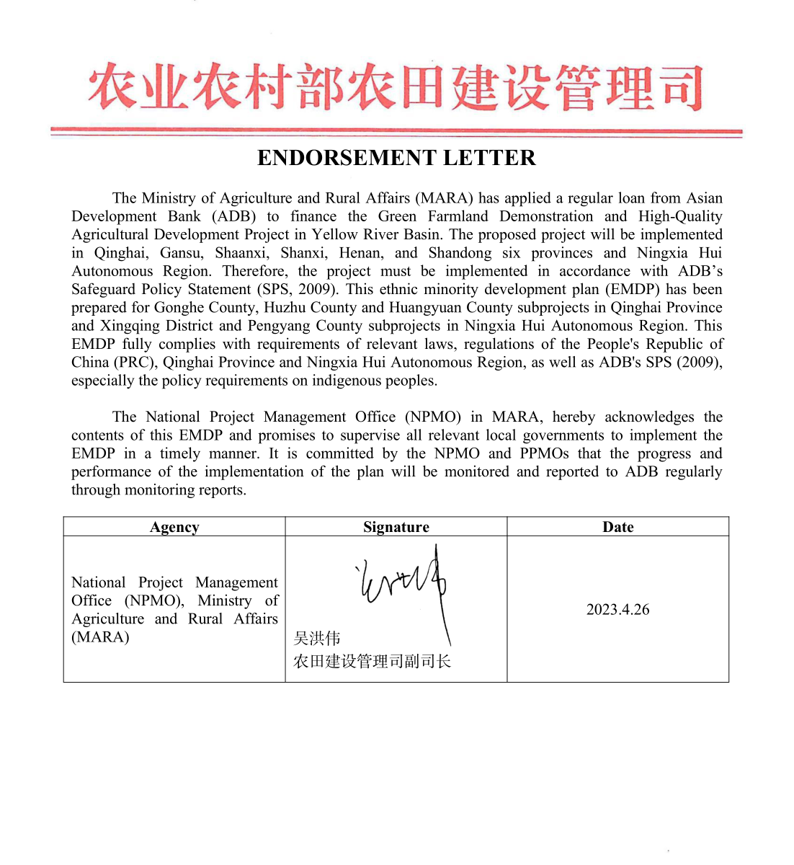

ABBREVIATIONS

ADB |  |  | – | Asian Development Bank
BARA |  |  | – | Bureau of Agriculture and Rural Affairs
BEE |  |  | – | Bureau of Ecology and Environment
CAB |  |  | – | Civil Affairs Bureau
CPMO |  |  | – | county project management office
CRP |  |  | – | compliance review panel
DI |  |  | – | design institute
DARA |  |  | – | Department of Agriculture and Rural Affairs
EM |  |  | – | ethnic minority
EMDF |  |  | – | ethnic minority development framework
EMDP |  |  | – | ethnic minority development plan
ERAC |  |  | – | Ethnic and Religious Affairs Commission
FGD |  |  | – | focus group discussion
FSR |  |  | – | feasibility study report
HH |  |  | – | household
LURT |  |  |  | land use right transfer
LURPI |  |  | – | land use for rural public infrastructure
M&E |  |  | – | monitoring and evaluation
MLSS |  |  | – | minimum living standard security
NRB |  |  | – | Natural Resource Bureau
KII |  |  | – | key informant interview
GRM |  |  | – | grievance redress mechanism
MARA |  |  | – | Ministry of Agriculture and Rural Affairs
NPMO |  |  | – | national project management office
O&M |  |  | – | operation and maintenance
OSPF |  |  | – | Office of the Special Project Facilitator
PIU |  |  | – | project implementation unit
PPMO |  |  | – | provincial project management office
PRC |  |  | – | People’s Republic of China
SPS |  |  | – | Safeguard Policy Statement
TrTA |  |  | – | transaction technical assistance
YREC |  |  | – | Yellow River Ecological Corridor

Table of Contents
Endorsement Letter i
EXECUTIVE SUMMARY 1
1 Introduction 6
2 Project Description 8
3 Ethnic Minority Distribution in Project Areas 11
4 PRINCIPLE AND Legal Framework of EMDP 17
4.1 Principle of the EMDP 17
4.2 Legal Framework 17
4.2.1 Policy on Ethnic Minorities of the PRC 17
4.2.2 ADB’s Policy Requirements on Indigenous Peoples 18
5 Socio-economic conditions of Ethnic Minorities in the Project Area 20
5.1 Characteristics of EMs 20
5.2 Social and Economic Profile of Ethnic Minorities in the Subproject Areas 20
5.2.1 Gender Analysis 20
5.2.2 Low Income Group 25
5.2.3 Education 26
5.2.4 Employment 27
5.2.5 Social and Cultural Features of EM Groups 27
6 Project Benefits and Impacts 29
6.1 Project Benefits 29
6.2 Project Adverse Impacts or Potential Risks and Mitigation Measures 30
7 Consultation, Participation and Disclosure 33
7.1 Public Participation Activities Conducted during the Project Preparation 33
7.2 Consultation and Participation during Project Implementation 37
7.2.1 Project Preparation Stage 37
7.2.2 Implementation Stage 37
7.2.3 Operation Stage 37
8 Ethnic minority action plan: Measures for Ethnic Minoriyt Development under Non-core Subprojects 39
9 Grievance Redress Mechanism 42
10 Implementation and Institutional Arrangements 44
11 Budget and Financing Sources 45
12 Monitoring and Evaluation 45
Appendix I: Photos of Field Survey 48

List of Tables

Table 3-1: Population and Ethnic Composition of the Project Provinces 11
Table 3-2: Beneficiaries and EMs Composition of the 17 Non-core Subproject Areas 12
Table 5-1: Population and Ethnic Composition in the Subproject Area 20
Table 5-2: Female EMs in the Subproject Areas 20
Table 5-3: Education Status of EM by Sex 21
Table 5-4: Employment Status of EM by Sex 22
Table 5-5: EMs of training participants by Sex 23
Table 5-6: EMs of Decision Making in Family Labor Production by Sex 24
Table 5-7: EMs in Public Affairs Participation by Sex 24
Table 5-8: The Low-Income of EMs in the Subproject Areas 25
Table 5-9: Education Status of EMs in the Subproject Areas of Qinghai and Ningxia 26
Table 5-10: Employment Status of EMs in the Subproject Areas of Qinghai and Ningxia 27
Table 6-1: Training and Technology Promotion for EM 29
Table 6-2: Job Creation for Ethnic Minorities of the Gonghe, Huzhu, Huangyuan, Xingqing and Pengyang Subprojects 29
Table 6-3: Project Positive and Adverse Impact/Risks 32
Table 7-1: Public Participation in Project Areas of Qinghai and Ningxia 35
Table 7-2: Participation Procedures for EM Residents at all Stages 38
Table 8-1: Ethnic Minority Action Plan for the Non-Core Subprojects in Gonghe, Huzhu, Huangyuan, Xingqing and Pengyang 39
Table 9-1: Focal Points of EMDP assigned with the five non-core subprojects 43
Table II-12-1: Budget Estimates of Action Plan for Ethnic Minority Development 46

EXECUTIVE SUMMARY

- Project Description/Introduction

- The Green Farmland Demonstration and High-Quality Agricultural Development Project in Yellow River Basin is to promote sustainable and resilient agricultural and food systems. The project will adopt a sector loan modality. Considering the subproject preparation readiness, geographical distribution, activity types and demonstration, among the 24 counties in 7 project provinces (autonomous region) in Yellow River Basin, 7 counties (one in each province) have been selected as core-subprojects, involving 26 townships and 147 village committees, and 17 non-core subprojects involving 48 townships and 255 village committees. The project has three outputs, including (i) Institutional, technical and management capacity and coordination strengthened; (ii) Green and climate resilient agricultural production bases developed; and (iii) Agricultural value chains strengthened. The activities include (i) farmland infrastructure construction; (ii) farmland protection and ecological environment improvement; (iii) soil and water conservation; (iv) agricultural value chain development; (v) science and technology support and capacity building.

- A due diligence on indigenous peoples (IP) in project area has been conducted during the project appraisal and concluded that the project is classified as category B in terms of indigenous peoples safeguard. An ethnic minority development framework (EMDF) has been prepared to guide the screening, assessment of social impacts, and preparation of the ethnic minority development plan (EMDP) for non-core subprojects following the ADB Safeguard Policy Statement (2009) and relevant PRC laws and regulations. According to the approved EMDF, an EMDP is needed to be prepared for the non-core subprojects including Gonghe County, Huzhu County and Huangyuan County subprojects in Qinghai Province and Xingqing District and Pengyang County subprojects in Ningxia Hui Autonomous Region since these five subprojects involved ethnic minorities (mainly Hui, Tu and Tibetan).

- Objectives of EMDP

- The EMDP is designed to ensure that ethnic minorities can directly participate in and benefit equally from the Project. Any adverse effects that might affect them will be avoided or mitigated. The EMDP is based on relevant laws and regulations of the People’s Republic of China (PRC), and in accordance with the Asian Development Bank’s (ADB) Safeguard Policy Statement (SPS 2009). The project is committed to incorporating inclusive features into the planning and design of project components to ensure equality or increase access of project benefits for ethnic minority groups, women, and low-income residents.

- The EMDP targets non-core subprojects involving impacts on ethnic minorities, which will be implemented in Tiegai Township, Longyangxia Town of Gonghe County, Donggou Township of Huzhu County and Heping Township of Huangyuan County in Qinghai and Yueyahu Township of Xingqing District, and Baiyang Town, Xinji Township and Gucheng Town of Pengyang County in Ningxia. Tiegai Township, Longyangxia Town and Heping Township involve mainly Tibetan and Hui; Donggou Township involves mainly Tu; and Yueyahu Township, Baiyang Town, Xinji Township and Gucheng Town involve mainly Hui.

- Legal Framework of EMDP

- The EMDP is formulated in accordance with relevant laws, regulations and policy of PRC and ADB SPS. The Constitution of the PRC (amended on 11 March 2018), the law of PRC on Regional Autonomy for Ethnic Minorities (2001), and the law of the PRC on the Standard Spoken and Written Chinese language (2001) clearly stipulate: (i) guarantee the exercise and respect of the rights of ethnic minorities; and (ii) promote the economic, social and cultural development of ethnic minorities. The ADB’s SPS (2009) outlines the requirements that ADB’s borrowers/clients need to implement social safeguards for ADB supported projects. The main objective of ADB's indigenous peoples safeguard is to ensure that indigenous peoples (i) receive culturally appropriate social and economic benefits; (ii) are not adversely affected by the project; (iii) are able to actively participate in projects that affect them.

- Overview of Ethnic Minorities in the Project Area

- Distribution of Ethnic Minorities. The 17 non-core subprojects involve 48 townships, including one ethnic township (Yueyahu Township in Xingqing District). The non-core subprojects involve 255 villages, including 25 ethnic minority villages. The total ethnic minority population was 24,083, accounting for 2.37% of the total beneficiaries in the 17 non-core subproject areas. Except Huzhu Tu Autonomous County, Gonghe County and Huangyuan County in Qinghai and Xingqing District and Pengyang County in Ningxia, there are no ethnic minority communities in the other 12 non-core subprojects areas. Ethnic minorities in project area in Huzhu County, Qinghai Province, account for about 67.94% of the total project beneficiaries in this county. In addition, the proportion of ethnic minorities in project areas in Gonghe County and Huangyuan County in Qinghai and Xingqing District and Pengyang County in Ningxia is 38.81%, 26.99%, 44.27% and 61.78%, respectively. Based on interviews and meetings with local residents and the Ethnic and Religious Affairs Commission (ERAC), the socioeconomic profiles of ethnic minorities, mainly Hui (Muslim,51.59%), Tu (Vajrayana Buddhist, 27.7%) and Tibetan (Vajrayana Buddhist,18.36%), in the non-core subprojects of Qinghai and Ningxia was assessed.

- Low income. There are 23,667 EMs in Gonghe County, Huzhu County, and Huangyuan County, Xingqing District and Pengyang County non-core subproject areas, including 4,698 low-income people, accounting for 19.85%. Among the 4,099 ethnic minority beneficiaries in the Gonghe County subproject area, 861 are low-income people, accounting for 21%. The ethnic minority population in Huzhu County subproject area is 6,780, and the low-income people is 1,309, accounting for 19.3%. The ethnic minority population in Huangyuan County subproject area is 577, and the low-income people is 105, accounting for 18.2%. Among the 7,281 ethnic minority beneficiaries in the Xingqing District subproject area, 1,413 are low-income people, accounting for 19.4% The ethnic minority population of Pengyang County subproject area is 4,930, and the low-income people is 1,012, accounting for 20.52%.

- Education level. According to the households surveys, the 736 valid samples include 186 Hui, 92 Tibetan, 85 Tu, 1 Manchun, 4 Mongolian and 368 Han. From the comparison of the education status of the respondents, the proportion of Hui (27.96%) is the highest, followed by Tu (27.06%), Han (23.10%) and Tibetan (17.39%) in primary school. In terms of junior middle school education, the proportion of Han (45.92%) is the highest, followed by Tu (45.88%) and Tibetan (40.22%), Hui (29.89%) is the lowest. In terms of senior high school and technical secondary education, Tibetan (20.65%) is the highest, Hui (15.59%) is the second, and Tu (10.59%) is the lowest. In terms of college or above education, Tibetan (17.39) is the highest, followed by Hui (10.22%), and Tu (2.35%) is the lowest . Among the four Mongolian respondents, 50% have junior school education and 50% have senior school education.

- Employment. From the comparison of the employment status of the respondents among ethnic groups, the proportion of professional farmers is the highest among the Han respondents (62.77%), followed by Hui (58.06%), Tu (55.29%) and Tibetan (51.09%). Among the respondents of farmers with other jobs, Tu (29.41%) are the highest, followed by Hui (23.66%), Han (23.64%), and Tibetan (19.57%) is the lowest. Among the respondents of local odd jobs, Tibetan (10.87%) is the highest, followed by Han (2.72%) and Tu (2.35%). Among the respondents of out-migration for work, Tibetan (6.52%) is the highest, followed by Tu (2.35%)

- Project Benefits and Impacts

- Project Benefits

- Capacity Building. The project will strengthen the capacity building of new agricultural enterprises through training and study tours, and provide farmers with technical promotion training on modern agricultural management knowledge, agriculture-related policies and regulations, and agricultural product quality and safety. The training targets are farmers in the project area, including ethnic minority farmers.

- Jobs and income-generation opportunities. The project will increase household income by hiring local ethnic minority families with surplus labor to participate in the project construction. For those who go out to work, they can also contribute to local income by participating in construction projects without having to go out to work.

- Improve the basic conditions of agricultural production and increase income. This project will help improve the basic conditions of agricultural production, improve the land comprehensive production capacity, increase food production, improve the utilization efficiency of resources such as water, fertilizer, reduce agricultural non-point source pollution, improve the quality and efficiency of agriculture, speed up the transformation of traditional agriculture to modern agriculture, so as to realize the comprehensive promotion of the rural economy and the speeding up of the farmers' income growth. This is expected to benefit farmers in the project area, including ethnic minority farmers.

- Reduce the cost of agricultural activities. The project will reduce the consumption of pesticides and fertilizers, improve the quality and competitiveness of agricultural products, and reduce ethnic minority labor burden and environmental pollution through the acquisition of pest control equipment, soil testing and formulation fertilization, and the promotion of biopesticides and organic fertilizers. This is expected to benefit residents in the project area, including ethnic minority residents.

- Adverse Impacts or Potential Risks and Mitigation Measures

- Inappropriate voluntary land use process. Voluntary land use including the approaches of land use right transfer (LURT) or land use for rural public infrastructure (LURPI) will be conducted through land use contracts negotiated and signed between the land user and land contractor including EMs. Any improper land transfer contract may affect the rights and interests of farmers, therefore, a LURT/LURPI framework has been prepared to ensure all land use contracts are conducted in a voluntary and fair way. During the implementation phase, LURT/LURPI will be monitored and verified by a land use specialist.

- Construction disturbances. The project mainly involves the construction of agricultural infrastructure such as irrigation, production roads, which may cause some disturbance to farmers, including the ethnic minority groups, during project implementation stage. The project will inform farmers of construction information and arrange construction time properly to avoid or minimize the temporary disturbances.

- Risks due to poor operation and maintenance of facilities. The agricultural infrastructure built by the project will greatly promote the development of local agriculture and reduce the labor burden of farmers. However, these infrastructures will need proper operation and maintenance (O&M) by rural collectives and farmer households. The project will establish a sound O&M system, and farmers will participate in the O&M to ensure social sustainability after project completion.

- Production cost increase due to change in fertilizers or planting structures. The project will involve changing agricultural cultivation methods, such as promoting organic or soil-formulated fertilizers, or adjusting cropping structures that may affect farmers' planting skills or increase the cost of agricultural production. The project will provide skills training and services for farmers without any charge.

- Information Disclosure, Public Consultation, and Grievance Redress Mechanism

- Tibetan, Hui, Tu and Mongolia residents have been consulted on the possible positive and negative impacts or risks of the project. They will benefit directly from the project. Focus group discussions (FGDs), key informant interviews (KIIs), household (HH) questionaries survey, and other consultation activities revealed that EMs in project areas support the proposed project and anticipate to benefit from the project. Their needs, concerns and suggestions have been taken into account during the EMDP preparation and project design. Further consultations and community mobilization activities will be conducted during project implementation. EMDP will be disclosed on ADB’s website and will be distributed to the relevant village committees and township government committees in a form understandable to the ethnic minorities and other stakeholders. For those ethnic minorities lacking reading skills, the heads of ethnic minority villages will be invited to explain the contents of EMDP in oral using local dialect. Consultations, participation and monitoring will continue during project implementation.

- Various methodologies were used in data collection and in consultation with various stakeholders. From September 2021 to March 2023, questionnaire surveys were conducted in the project area, FGDs and KIIs were held with stakeholders of the Bureau of Agriculture and Rural Affairs (BARA, where the county project management office - CPMO is set up), Water Resources Bureaus, Bureau of Ecology and Environment (BEE), Women's Federations, Rural Development Bureaus, Civil Affairs Bureaus (CAB), Natural Resources Bureaus (NRB) and ERAC (Qinghai and Ningxia).

- From September to December 2021, social survey team disclosed relevant project information, and conducted extensive participation and consultation with project stakeholders, including EMs. 525 HHs questionaries survey in Qinghai and Ningxia and other consultation activities revealed that EMs in project areas support the proposed project and anticipate benefiting from the project.

- From January to March 2023, TrTA social team conducted supplementary surveys, which covered 211 HH questionnaires and 2 FGDs (virtual meetings) in three non-core subprojects including Huangyuan County, Gonghe County, and Huzhu County in Qinghai Province, mainly to understand the views, needs, and attitudes of ethnic minorities, especially Tibetans, in the project areas. Their needs, concerns and suggestions have been taken into account during the project feasibility study and EMDP preparation.

- A Grievance Redress Mechanism (GRM) has been established to ensure that any complaints and appeals related to the project raised by EMs are identified, documented, discussed and resolved in a timely and effective manner.

- Implementation and Institutional Arrangements

- The Qinghai and Ningxia provincial project management offices (PPMOs) will be responsible for supervising and monitoring the EMDP implementation; the Gonghe County, Huzhu County, Huangyuan County, and Xingqing District and Pengyang County CPMOs will be responsible for implementing the EMDP. The PPMOs and CPMOs will be assisted by the social consultants, who will be hired by PPMOs during project implementation. Other key agencies for the implementation of the EMDP include the BARA, Rural Revitalization Bureau, CAB, Rural Development Bureaus, ERAC, Women's Federation and other concerned agencies, in coordination with the township chief and the village chiefs and/or cadres who shall be the focal persons to facilitate linkages at the village level.

- Budget and Financing Sources

- The costs for EMDP implementation are included in (i) the project budget or (ii) the day-to-day management costs of relevant local government departments. Local PMOs will also coordinate actions taken by the corresponding county government in each project area. National Project Management Office (NPMO), PPMOs, CPMOs and local government staff and related costs will be covered by the relevant government administrative budget.

- Monitoring, Evaluation and Reporting

- During the implementation stage of the Project, monitoring, evaluation and reporting on the EMDP implementation is required to ensure the plan is implemented properly. NPMO, PPMO and CPMOs will take the responsibilities of monitoring of EMDP implementation progress. They will mobilize social focal staff (at least one person per agency) under their respective PMOs to work on the project’s EMDP matters. Meanwhile, a social specialist, hired by the NPMO, will overall monitor and report the EMDP implementation progress and performance. Assistance and trainings will be provided for PMOs during the project implementation phase. Monitoring will be conducted until project completion. Consolidated semi-annual social monitoring reports (together with the other land use and social issues) will be submitted by NPMO to ADB.

Introduction

- The Green Farmland Demonstration and High-quality Agricultural Development Project in Yellow River Basic project is subject to the sector loan modality. Considering the subproject preparation readiness, geographical distribution, activity types and demonstration, among the 24 counties in 7 project provinces in Yellow River Basin, 7 counties of 7 Provinces have been selected as core-subprojects including: (i) Datong Hui and Tu Autonomous County in Qinghai; (ii) Anding District in Gansu; (iii) Qingtongxia in Ningxia; (iv) Dali County in Shaanxi; (v) Pinglu County in Shanxi; (vi) Shanzhou District in Henan; and (vii) Yanggu County in Shandong. All activities related to the other 17 counties in the 7 provinces were selected as the non-core subprojects including: (i) Gonghe County, Huzhu County and Huhangyuan County in Qinghai; (ii) Huining County and Kongdong District in Gansu; (iii) Xingqing District and Pengyang County in Ningxia; (iv) Yuyang District, Shenmu County and Nanniwan in Shaanxi; (v) Ruicheng County and Hejin City in Shanxi; (vi) Wuzhi County, Xiangfu District and Yanshi District in Henan; (vii) Ningyang County and Yuncheng County in Shandong.

- The non-core subprojects involve 48 townships, including one ethnic township. The non-core subprojects involve 255 villages, of which, 25 ethnic minority villages. In the 17 non-core subproject areas, the total ethnic minority population was 24,083, accounting for 2.37% of the total beneficiaries in non-core subproject areas. There are no ethnic minority communities in 12 non-core subprojects areas, including Huining County and Kongdong District in Gansu Province, Yuyang District, Shenmu City and Nanniwan in Shaanxi, Ruicheng County and Hejing City in Shanxi Province, Wuzhi County, Xiangfu District and Yanshi District in Henan Province, and Ningyang County and Yuncheng County in Shandong Province. Ethnic minorities in non-core subproject area of Huzhu County, Qinghai Province, accounting for the highest proportion, is about 67.94% of the beneficiaries. In addition, the proportion of ethnic minorities in Gonghe County and Huangyuan County non-core subproject area in Qinghai and Xingqing District and Pengyang County non-core subproject area in Ningxia is 38.81%, 26.99%, 44.27% and 61.78%, respectively.

- A due diligence on indigenous peoples (IP) in project area has been conducted and concluded that the project is classified as category B in terms of indigenous people safeguard. An EMDF has been prepared to guide the screening, assessment of social impacts, and preparation of the EMDP for non-core subprojects following the ADB Safeguard Policy Statement (2009) and relevant PRC laws and regulations.

- According to the EMDF, an EMDP needed to be prepared for non-core subprojects of Gonghe County, Huzhu County, Huangyuan County, Xingqing District and Pengyang County with ethnic minorities (mainly Tibetan, Hui and Tu). This EMDP is to ensure that ethnic minorities in the project areas benefit from the project in a cultural appropriate manner and to mitigate any negative impacts that the project may have on them. Provisions to improve the economic conditions of residents in the project areas, including ethnic minorities, women and low-income groups, have been incorporated into the project design. The EMDP is based on relevant laws and regulations of the PRC and is in line with the ADB’s SPS (2009). The EMDP describes relevant legal framework of the PRC, Qinghai Province and Ningxia Hui Autonomous Region on ethnic minorities, ADB’s IP safeguard requirements, socioeconomic situation, potential impacts of the project on ethnic minorities, and agreed measures for ethnic minorities.

- The 17 non-core subprojects involve 48 townships, including one ethnic township, and 255 villages, 25 of which are ethnic minority villages. The total ethnic minority population is 24,083, accounting for 2.37% of the total beneficiaries in the seventeen non-core subproject areas, which are mainly distributed in Gonghe County, Huzhu County, Huangyuan County in Qinghai Province and Xingqing District, Pengyang County in Ningxia. Among these ethnic minorities, 51.59% are Hui, 27.7% are Tu and 18.36% are Tibetan. The EMDP covers the following five non-core subproject areas, including Gonghe County, Huzhu County, Huangyuan County in Qinghai Province and Xingqing District, Pengyang County in Ningxia Hui Autonomous Region.

- A combination of different approaches and methods was adopted to prepare the EMDP. Tibetan, Hui and Tu residents have been consulted on the possible positive and negative impacts or risks of the project. They will benefit directly from the project. (i) From September to December 2021, social survey team disclosed relevant project information, and conducted public participation and consultation with project stakeholders, including EMs. 525 HHs questionnaires survey in Qinghai and Ningxia and other consultation activities revealed that EMs in project areas support the proposed project and anticipate benefitting from the project. (ii) From January to March 2023, TrTA conducted supplementary 211 HH questionnaires and 2 FGDs (online form) in three non-core subprojects including Huangyuan County, Gonghe County, and Huzhu County in Qinghai Province, mainly to understand the views, needs, and attitudes of ethnic minorities, especially Tibetans, in the project areas. Their needs, concerns and suggestions have been taken into account during the project feasibility study and EMDP preparation.

Project Description

- The project consists of three outputs: (i) Output 1: Institutional, technical and management capacity and coordination strengthened. This output will address the issue of insufficient institutional capacity and coordination which inhibits agriculture sector development and environmental protection along the Yellow River. (ii) Output 2: Green and climate resilient agricultural production bases developed. This output will address the outdated and inefficient agricultural production system issues which constrain production efficiencies and limits farmer income potential. (iii) Output 3: Agricultural value chains strengthened. This output will address the constraints faced by agribusinesses that hamper their ability to add value to food and agricultural raw products through processing, storing, and marketing their products. The proposed activities in the non-core subprojects are in Table 2-1.

Table 2-1: 5 Non-Core Subprojects and Activities Proposed
Province | City | County | Activities
Output1: Institutional, technical and management capacity and coordination strengthened
Output2: Green and climate resilient agricultural production bases developed
Qinghai | Hainan Prefecture | Gonghe | Terraces
 |  |  | Topsoil protection
 |  |  | Newly built water storage tank
 |  |  | Relief tank and valve well
 |  |  | Low pressure pipe irrigation
 |  |  | Field trunk road: gravel road, passing land
 |  |  | Farming road: gravel road
 |  |  | Farmland project signs
 |  |  | Straw returning back to field: covering area, equipment
 |  |  | Subsoiling
 |  |  | Soil testing and formula fertilization
 |  |  | Organic fertilizer promotion
 |  |  | Pest control equipment
 |  |  | Biological pesticide promotion
 |  |  | Promotion of standard plastic film
 |  |  | Promotion of degradable plastic film
 |  |  | Recycling facilities
 |  |  | Recycling equipment
 |  |  | Resource utilization of livestock and poultry manure: facilities, equipment
Qinghai | Haidong | Huzhu | Terraces
 |  |  | Topsoil protection
 |  |  | Newly built water storage tank
 |  |  | Relief tank and valve well
 |  |  | Low pressure pipe irrigation
 |  |  | Field trunk road: gravel road, passing land
 |  |  | Farming road: gravel road
 |  |  | Farmland project signs
 |  |  | Straw returning back to field: covering area, equipment
 |  |  | Subsoiling
 |  |  | Soil testing and formula fertilization
 |  |  | Organic fertilizer promotion
 |  |  | Pest control equipment
 |  |  | Biological pesticide promotion
 |  |  | Promotion of standard plastic film
 |  |  | Promotion of degradable plastic film
 |  |  | Recycling facilities
 |  |  | Recycling equipment
 |  |  | Resource utilization of livestock and poultry manure: facilities, equipment
Qinghai | Xining | Huangyuan | Newly built water storage tank
 |  |  | Newly built water pipeline
 |  |  | Bridge
 |  |  | Pipe culvert
 |  |  | Relief tank and valve well
 |  |  | Field trunk road: hardened road, gravel road,passing land
 |  |  | Farming road:graval road
 |  |  | Farmland project signs
 |  |  | Straw returning to field: covering area, equipment
 |  |  | Green manure planting
 |  |  | Soil testing and formula fertilization
 |  |  | Organic fertilizer promotion
 |  |  | Intelligent irrigation system
 |  |  | Pest control equipment
 |  |  | Biological pesticide promotion
 |  |  | Promotion of standard plastic film
 |  |  | Promotion of degradable plastic film
 |  |  | Recycling facilities
 |  |  | Recycling equipment
 |  |  | Rehabilitation of farmland shelterbelt
 |  |  | Dike
 |  |  | Check dam
 |  |  | Ground sills
 |  |  | Ecological ridge
 |  |  | Resource utilization of livestock and poultry manure: facilities, equipment
 |  |  | Soil and water conservation forest
Ningxia | Yinchuan | Xingqing | Strip field
 |  |  | Water measuring facilities
 |  |  | Water inlet anchor gate
 |  |  | Pipe culvert
 |  |  | Relief tank and valve well
 |  |  | Micro irrigation (including drip irrigation)
 |  |  | Field trunk road：hardened road
 |  |  | Farming road：hardened road
 |  |  | Farmland project signs
 |  |  | Promotion of soil conditioner
 |  |  | Straw returning back to field：covering area，facilities，equipment
 |  |  | Soil testing and formula fertilization
 |  |  | Organic fertilizer promotion
 |  |  | Fertigation pump station
 |  |  | Intelligent irrigation system
 |  |  | Pesticide reduction and harm control
 |  |  | Pest control equipment
 |  |  | Biological pesticide promotion
 |  |  | Promotion of degradable plastic film
 |  |  | Recycling facilities
 |  |  | Recycling equipment
 |  |  | Farmland ecological landscape and isolation zone
 |  |  | Biological channel
Ningxia | Guyuan | Pengyang | Terraces
 |  |  | Newly built water storage tank
 |  |  | Water measuring facilities
 |  |  | Micro irrigation (including drip irrigation)
 |  |  | Field trunk road：hardened road
 |  |  | Farming road：hardened road，gravel road
 |  |  | Farmland project signs
 |  |  | Promotion of soil conditioner
 |  |  | Straw returning back to field：covering area，facilities
 |  |  | Soil testing and formula fertilization
 |  |  | Organic fertilizer promotion
 |  |  | Fertigation pump station
 |  |  | Intelligent irrigation system
 |  |  | Pesticide reduction and harm control
 |  |  | Pest control equipment
 |  |  | Biological pesticide promotion
 |  |  | Promotion of degradable plastic film
 |  |  | Ditch head protection
 |  |  | Soil and water conservation forest
Output3: Agricultural value chains strengthened
Qinghai | Hainan Prefecture | Gonghe | Cold chain logistics vehicle
 |  |  | Facilities and equipment
Qinghai | Haidong | Huzhu | Cold chain logistics vehicle
 |  |  | Civil works
 |  |  | Facilities and equipment
Qinghai | Xining | Huangyuan | Cold chain logistics vehicle
Ningxia | Yinchuan | Xingqing | Fruit and vegetable greenhouse
 |  |  | Cold chain equipment
 |  |  | Cold chain logistics vehicle
 |  |  | Fresh keeping cold chain facilities
Source: FSR prepared in December 2022, Design Institutes, July-November 2022.

Ethnic Minority Distribution in Project Areas

- Provincial level. According to the Feasibility Study Report (FSR), the project will cover 24 counties in 7 provinces (autonomous region) along the Yellow River Basin. According to the secondary socio-economic data of the project provinces, ethnic minority accounting for about 10% - 50% in Qinghai Province (49.47%), Gansu Province (10.62%) and Ningxia (35.95%) (Table 3-1).

Table 3-1: Population and Ethnic Composition of the Project Provinces
Province | Population | EMs |  | The First Major Ethnic Group
 | 10,000 | 10,000 | % | Nationality | 10,000 | %
Qinghai | 592.8 | 293.04 | 49.47 | Tibetan | 153.35 | 52.88
Gansu | 2,501.98 | 265.64 | 10.62 | Hui | 205.88 | 8.23
Ningxia | 720.27 | 258.97 | 35.95 | Hui | 252.36 | 97.45
Shaanxi | 3,952.9 | 22.27 | 0.56 | Hui | 13.45 | 84.1
Shanxi | 3,491.56 | 12.14 | 0.35 | Hui | 6.08 | 50.08
Henan | 9,936.6 | 115.5 | 1.16 | Hui | 123.19 | 85.4
Shandong | 10,152.7 | 90.5 | 0.89 | Hui | 53.3 | 58.89
EM = ethnic minority.
Source: Data from PPMOs.

- County/district level. Among 24 project counties, there are two ethnic minority autonomous counties in total (e.g., Datong Hui Tu Autonomous County and Huzhu Tu Autonomous County in Qinghai Province). At the project county level in Qinghai, Gansu and Ningxia, the proportion of ethnic minorities is 3%-75%, the highest is 74.24% in Gonghe County, Qinghai Province.

- In the Gonghe County, Huzhu Tu Autonomous County, and Huangyuan County of Qinghai Province, ethnic minorities account for 74.24%, 60.84%, 28.16% and 15.49% respectively. In the Kongdong District, Huining County and Anding District of Gansu Province, ethnic minorities account for 23.7%, 3.25%, 3.02%, respectively.

- In Pengyang County, Qingtongxia City and Xingqing District of Ningxia Hui Autonomous Region, ethnic minorities account for 30.42%, 22.57%, 21.4%, respectively.

- In Kongdong District subproject area of Gansu Province, the ethnic minority population accounts for 0.29% of the total beneficiaries. According to interviews with local CPMO, the ERAC and the residents of the project area, the project areas involved have no ethnic minority communities, only have 389 scattered ethnic minority population who are mainly engaged in business in the town.

- See more details of EM distribution in project area in Table 3-2.

Table 3-2: Beneficiaries and EMs Composition of the 17 Non-core Subproject Areas
Province | City/  County/  District | Towns |  |  | Administrative villages |  |  |  | Population | EMs |  | The First Major Ethnic Group
 |  | Name | No. | EM Town | Name | No. | EM Village |  | Persons | No. | % | EM | Persons
 |  |  |  | (Yes/No) |  |  | No. | Name
Qinghai | Gonghe County | Tiegai | 1 | No | Mahantai, Hahantuhai, Lacai, Qitai, Shangheyuesi, Tiegai, Tuoletai, Weiqu, Wulei, Xiaheyuesi | 10 | 10 | Lacai, Mahantai, Shangheyuesi, Tiegai, Hahantuhai, Weiqu, Wulei, Xiaheyuesi | 6,391 | 2,834 | 44.34 | Tibetan | 2,719
 |  | Longyangxia | 1 | No | Desheng, Caoduolong, Cihantuhai, Houjuhua | 4 | 4 | Desheng, Caoduolong, Cihantuhai, Houjuhua | 4,172 | 1,265 | 30.32 | Tibetan | 1,102
 | Huzhu County | Donggou | 1 | No | Longyi, Longer, Nianxian, Kazi, Luoshao, Gounao, Kouzi, Dazhuang | 8 | 8 | Longyi, Longer, Nianxian, Kazi, Luoshao, Gounao, Kouzi, Dazhuang | 9,979 | 6,780 | 67.94 | Tu | 6,555
 | Huangyuan County | Heping | 1 | No | Xiaogaoling Village | 1 | 1 | Xiaogaoling Village | 2,138 | 577 | 26.99 | Tibetan | 524
 | Subtotal | / | 4 | / | / | 23 | 23 | / | 22,680 | 11,456 | 50.51 | / | 10,900
Gansu | Huining County | Hanji | 1 | No | Yuanjiaju Village, Yuanjiaping Village,Hanjiaji Village, Goujiaxian Village, Yuntaishan Village | 5 | 0 | / | 15,761 | 0 | 0.00 | / | 0
 |  | Sifangwu | 1 | No | Xiaonancha Village, Danancha Village, Sifangwu Village, Linjiawan Village, Fanjiagou Village, Sanfangwu Village | 6 | 0 | / | 18,557 | 0 | 0.00 | / | 0
 | Kongdong District | Sishilipu | 1 | No | Mayukou Village, Shangwan Village,Junzhang Village, Minzhang Village, Qifu Village, Meixian Village | 6 | 0 | / | 50,912 | 24 | 0.05 | Hui | 24
 |  | Baishui | 1 | No | Wangzhai Village, Malian Village, Dahu Village, Baishui Village, Mengzhai Village,Yongle Village, Shijiagou Village, Dapan Village, Dachen Village, Jiaozhuang Village | 10 | 0 | / | 30,037 | 265 | 0.88 | Hui | 265
 |  | Huasuo | 1 | No | Sigou Village, Xinhe Village, Guangming Village, Huasuo Village, Duangou Village | 5 | 0 | / | 18,535 | 100 | 0.54 | Hui | 100
 | Subtotal | / | 5 | / | / | 32 | / | / | 133,802 | 389 | 0.29 | / | 389
Ningxia | Xingqing District | Yueyahu | 1 | Yes | Binghejiayuan First Village, Binghejiayuan Second Village, Binghejiayuan Third Village, Binghejiayuan Forth Village, Datangbei Village | 5 | 5 | Binghejiayuan First Village, Binghejiayuan Second Village, Binghejiayuan Third Village, Binghejiayuan Forth Village, Datangbei Village | 16,446 | 7,281 | 44.27 | Hui | 7,279
 | Pengyang County | Baiyang | 1 | No | Zhongzhuang Village, Yaoxian Village | 2 | 0 | / | 3,267 | 1,420 | 43.46 | Hui | 1,420
 |  | Xinji | 1 | No | Baicaowa Village, Zhaogou Village | 2 | 0 | / | 2,309 | 2,309 | 100.00 | Hui | 2,309
 |  | Gucheng | 1 | No | Wengou Village | 1 | 0 | / | 2,404 | 1,201 | 49.96 | Hui | 1,201
 | Subtotal | / | 4 | / | / | 10 | 5 | / | 24,426 | 12,211 | 49.99 | / | 12,209
Shaanxi | Yuyang District | Guta | 1 | No | Zhangleigou Village, Songshumao Village, Luojian Village | 3 | 0 | / | 3,899 | 0 | 0.00 | / | 0
 |  | Qingyun | 1 | No | Fengshan Village | 1 | 0 | / | 1,385 | 0 | 0.00 | / | 0
 |  | Yuhe | 1 | No | Xinjian Village, Yuhe Village,Lijiagou,Liangqu Village,Gaojiawa Village, Yuhe Farm,Ganhe Branch Farm of Yuhe, Yuhe Forestry Centre | 8 | 0 | / | 11,855 | 0 | 0.00 | / | 0
 |  | Jinjitan | 1 | No | Jinjitan Village, Hailiutan Village,Shanghe Village | 3 | 0 | / | 6,424 | 0 | 0.00 | / | 0
 |  | Chaoyanglu Office | 1 | No | Sanchawan Village, Liuguanzhai Village, Guidebao Village, Sanchen Community | 4 | 0 | / | 6,950 | 0 | 0.00 | / | 0
 | Shenmu City | Gaojiabao | 1 | No | Sangshuqu Village, Sangshuta Village, Qingyangshugou Village, Gujintan Village, Muguashan Village, Hedonggou Village, Lamahe Village, Lamagou Village, Lijiadong Village, Xujiata Village, Liangshuijing Village, Shuimo Village, Xuanluta Village, Taihewan Village, Gaojiabao Village, Majiatan Village, Qiaochatan Village, Liujiapan Village,Hexingmao Village | 19 | 0 | / | 27,766 | 0 | 0.00 | / | 0
 | Nanniwan | Nanniwan | 1 | No | Chenzigou Village, Songshulin Village, Mizhuang Village, Maping Village, Dengtun Village, Jinbian Village | 6 | 0 | / | 5,136 | 0 | 0.00 | / | 0
 |  | Madongchuan | 1 | No | Shiyaowan Village, Madongchuan Village,J inpenwan Village | 3 | 0 | / | 4,497 | 0 | 0.00 | / | 0
 | Subtotal | / | 8 | / | / | 47 | / | / | 67,912 | 0 | / | / | 0
Shanxi | Ruicheng County | Fenglingdu | 1 | No | Beijieyi Village | 1 | 0 | / | 2,282 | 0 | 0.00 | / | 0
 |  | Yongle | 1 | No | Yongle Village, Cai Village | 2 | 0 | / | 7,574 | 0 | 0.00 | / | 0
 |  | Nanwei | 1 | No | Xinnanzhang Village, Dongzhanglian Village, Laozhuanglian Village | 3 | 0 | / | 7,562 | 0 | 0.00 | / | 0
 |  | Ximo | 1 | No | Zhuyang Village, Jiagou Village | 2 | 0 | / | 4,823 | 0 | 0.00 | / | 0
 | Hejing City | Xiaoliang | 1 | No | Xiliang Village | 1 | 0 | / | 3,020 | 0 | 0.00 | / | 0
 |  | Yangcun Street | 1 | No | Lianbo Village | 1 | 0 | / | 5,945 | 0 | 0.00 | / | 0
 | Subtotal | / | 6 | / | / | 10 | / | / | 31,206 | 0 | / | / | 0
Henan | Wuzhi County | Qiaomiao | 1 | No | Dihe Village, Fengzhang Village, Huang Village, Liuzhuang Village, Maxuanzhai Village, Meng Village,Songling Village, Yangwa First Street, Yangwa Second Street, Yangwa Third Street, Zhang Village | 11 | 0 | / | 44,000 | 0 | / | / | 0
 | Xiangfu District | Duliang | 1 | No | Lizhai Village, Chenzhai Village, Xiaozhuang Village,Jiazhaung Village, Madian Village, Xiaomenzhai Village, Damenzhai Village, Dakangzhai Village | 8 | 0 | / | 72,693 | 0 | / | / | 0
 | Yanshi District | Guxian | 1 | No | Guxian Village, Miaowan Village, Duandong Village, Duanxi Village, Liwan Village | 5 | 0 | / | 61,978 | 0 | / | / | 0
 |  | Gaolong | 1 | No | Puliu Village, Taohua Village, Zuocun village, Guotun Village, Datun Village | 5 | 0 | / | 38,586 | 0 | / | / | 0
 | Subtotal | / | 4 | / | / | 29 | / | / | 217,257 | 0 | / | / | 0
Shandong | Ningyang County | Huafeng | 1 | No | Hu Village, Manjia Village, Gaozhuang, Jinliangzhuang, Meijia Village, Xiadougou, Shangdougou, Dongjueshan, Yongyizhuang Village, Chenggongzhuang | 10 | 0 | / | 14,625 | 0 | 0.00 | / | 0
 |  | Dongzhuang | 1 | No | Dongzhuang Village, Dazhangzhuang Village, Xicuijia Village, Beibi Village, Xinghua Village, Beichen Village, Xihan Village | 7 | 0 | / | 7,337 | 0 | 0.00 | / | 0
 |  | Jiangji | 1 | No | Qiancaijiawa Village, Xingshanhou Village, Ningzhuang Village, Daan Village, Dahuai Village, Dongpeng Village, Xiaofu Village, Hejiatang Village, Lvjiazhuang Village, Zhonghe Village, Xicaijiawa Village, Qianpengjiazhuang Village, Guojiazhaung Village, Bada Village, Sanjing Village,Mazhuang Village, Shouan Village | 17 | 0 | / | 17,148 | 0 | 0.00 | / | 0
 |  | Ciyao | 1 | No | Caishanzhuang, Guojiazhuang, Housiwang Village, Siwangji Village | 4 | 0 | / | 6,083 | 0 | 0.00 | / | 0
 |  | Gangcheng | 1 | No | Gangchengbei Village | 1 | 0 | / | 1,573 | 0 | 0.00 | / | 0
 |  | Heshan | 1 | No | Dongshanqian Village, Taoyuan Village | 2 | 0 | / | 2,978 | 0 | 0.00 | / | 0
 |  | Fushan | 1 | No | Houguang Village | 1 | 0 | / | 1,650 | 0 | 0.00 | / | 0
 | Yuncheng County | Yuhuangmiao | 1 | No | Huangqiao Village, Nanhuangqiao Village, Xiaohuangqiao Village, Wuchakou Village, Dongmalou Village, Sanyi Village, Maliuzhuang Village, Machang Village, Echang Village, Liukounan Village | 6 | 0 | / | 44,334 | 0 | 0.000 | / | 0
 |  | Shuangqiao | 1 | No | Lianggai Village, Liuzhuang Village, Liangxi Village, Zhuzhuang Village, Yongfengji Village, Zhengzhuang Village, Lilou Village, Yihelou Village, Polihezhuang Village, Hzhuang Forest Centre, Tonglou Village, Guozhuang Village, Houhuanggang Village | 9 | 0 | / | 51,159 | 5 | 0.010 | Hui | 2
 |  | Chenpo | 1 | No | Chenpo Village, Fandouzhuang Village, Dawangmiao Village, Malou Village, Wawuzhuang Village, Yuge Village, Zhaoleizhuang Village | 6 | 0 | / | 31,818 | 19 | 0.060 | Hui | 7
 |  | Huangji | 1 |  | Luhutong Village,B ugetun Village, Wanghuaitang Village, Caoxi Village, Huangji Village | 5 | 0 |  | 44,834 | 3 | 0.007 | Yi | 2
 |  | Chengtun | 1 | No | Chengtun Village, Tongzhuang Village, Shouyiliuzhuang Village, Xiquzhuang Village, Beilizhuang Village, Nanqianlou Village | 5 | 0 | / | 61,133 | 0 | 0.000 | / | 0
 |  | Pandu | 1 | No | Tongba Village, Xuelou Village, Rentun Village | 3 | 0 | / | 51,005 | 0 | 0.000 | / | 0
 |  | Zhangying Street | 1 | No | Weigai Village, Yinlou Village, Wulou Village, Zhuhekou Vilaage, Zhonglou Village, Mazhuang Village | 6 | 0 | / | 45,358 | 0 | 0.000 | / | 0
 |  | Tangmiao | 1 | No | Zhaomeng Village, Wanglaohu Village, Houtun Village, Daliqiao Village, Mingguozhuang Village, Qianhouzhou Village, Qiantun Village, Xililou Village, Xialou Village, Yangtan Village, Zhongtun Village, Chennan Village | 8 | 0 | / | 41,372 | 0 | 0.000 | / | 0
 |  | Nanzhaolou | 1 | No | Shangying Village,Weizhuang Village,Yuanzhuang Village,Zhanghewan Village,Zhenzhuang Village,Zhengying Village | 6 | 0 | / | 32,937 | 0 | 0.000 | / | 0
 |  | Wuan | 1 | No | Wangyangzhuang Village, Doulou Village, Caofang Village, Matun Village, Qianhuzhaung Village, Sunlin Village, Jiangwan Village, Liuhuzhuang Village | 8 | 0 | / | 61,413 | 0 | 0.000 | / | 0
 | Subtotal | / | 17 | / | / | 104 | / | / | 516,757 | 27 | 0.01 | / | 11
 | Total |  | 48 | / | / | 255 | 28 | / | 1,014,040 | 24,083 | 2.37 | / | 23,509
EM = ethnic minority.
Source: Local CPMOs.

PRINCIPLE AND Legal Framework of EMDP

Principle of the EMDP

- The overall principle of the EMDP is to ensure that (i) the project will not adversely affect ethnic minorities; (ii) the project provides socially inclusive jobs and income-generation opportunities for local farmers, including ethnic minority groups; (iii) ethnic minorities can equally participate in and benefit from project activities in a culturally appropriate manner; and (iv) ethnic minorities are broadly engaged in project planning, implementation and monitoring.

- The project is committed to incorporating inclusive mechanisms into the planning and design of project construction elements to ensure equality or increase the effectiveness of project access for ethnic minority groups.

Legal Framework

Policy on Ethnic Minorities of the PRC

- The Government of the PRC defines the coverage of ethnic minorities to include all other nationalities except the Han nationality. The word “nationality” as defined by the PRC here refers to ethnic groups with small number of populations which explains why they are called ethnic minorities. The Han population comprises the largest (about 90%) among the 56 recognized ethnic nationalities in the country. The ethnic minorities’ rights and culture are well recognized and respected by the law. The PRC Constitution and Law of Regional Autonomy for Ethnic Minorities clearly stipulate several provisions that (i) guarantee the exercise and respect of ethnic minorities’ rights, and (ii) promote their economic and socio-cultural development.

- The key principles of the PRC’s ethnic minority policies can be briefly summarized as (i) strengthening ethnic equality and solidarity; (ii) administrative autonomy of ethnic minority regions; (iii) development of economy and cultures of ethnic minority regions; (iv) cultivation of ethnic minority cadres; (v) improvement of science, education, civilization, health, and other undertakings in ethnic minority regions; (vi) protection and the inheritance of ethnic languages; (vii) respect of ethnic minority customs and habits; and (viii) respect and protection of ethnic minorities’ freedom of religious beliefs. On the top of its state-building agenda, the PRC has been taking national unity, ethnic solidarity, ethnic equality, and mutual respect as the basic guidelines of managing ethnic affairs.

- The legal framework (national laws and regulations) protecting the ethnic minorities’ rights and other legal provisions that may apply for the project outputs and/or components, such as rights as citizens of the country, membership to collectives, utilization of resources, cultural and political rights, and others are summarized as follows.

- Constitution of PRC (amended on March 11, 2018). Article 4 All nationalities in the PCR are equal. The State protects the lawful rights and interests of the minority nationalities and upholds and develops a relationship of equality, unity and mutual assistance among all PRC’s nationalities. Discrimination against and oppression of any nationality are prohibited; any act which undermines the unity of the nationalities or instigates division is prohibited. The State assists areas inhabited by minority nationalities in accelerating their economic and cultural development according to the characteristics and needs of the various minority nationalities. Regional autonomy is practiced in areas where people of minority nationalities live in concentrated communities; in these areas organs of self-government are established to exercise the power of autonomy. All national autonomous areas are integral parts of the PRC. All nationalities have the freedom to use and develop their own spoken and written languages and to preserve or reform under rule of the law. Article 9 All mineral resources, waters, forests, mountains, grasslands, unreclaimed land, beaches and other natural resources are owned by the State, that is, by the whole people with the exception of the forests, mountains, grasslands, unreclaimed land and beaches that are owned by collectives as prescribed by law.

- Law of Regional Autonomy for EMs in PRC (2001). Article 23 When recruiting personnel in accordance with State regulations, enterprises and institutions in national autonomous areas shall give priority to minority nationalities and may enlist them from the population of minority nationalities in rural and pastoral areas. Article 65 While exploiting resources and undertaking construction in national autonomous areas, the State shall give consideration to the interests of these areas, make arrangements favorable to the economic development there and pay proper attention to the productive pursuits and the life of minority nationalities there. The State shall take measures to give due benefit compensation to the national autonomous areas from which the natural resources are transported out. Article 66 Where national autonomous areas make contribution to the ecological balance and environmental protection of the State, the State shall give them due benefit compensation. While exploiting resources and undertaking the construction in national autonomous areas, the organizations or individuals shall take effective measures to protect and improve local living and ecological environment and to prevent and control pollution and other public hazards.

- Law of the PRC on the Standard Spoken and Written Chinese Language (2001). Article 8 All the nationalities shall have the freedom to use and develop their own spoken and written languages. The spoken and written languages of the ethnic minorities shall be used in accordance with the relevant provisions of the Constitution, the Law on Regional Autonomy of EMs in PRC.

- In addition to the legal rights enjoyed by EMs, the Government of the PRC has worked to translate the legal rights of EMs into practice for their social, political, economic and cultural development by formulating and implementing the Five-year Plan for the Development of EMs. The main principles of the policy for the development of EMs can be summarized as follows: (i) strengthening equality and unity among EMs; (ii) increasing the income of ethnic minority families and improve the living standards of ethnic minority areas by developing infrastructure and social services; (iii) cultivating cadres of ethnic minorities; (iv) improving the level of education and health services in ethnic minority areas; (v) protection and the inheritance of ethnic languages; and (vi) protecting cultural heritages in ethnic minority regions.

ADB’s Policy Requirements on Indigenous Peoples

- Indigenous peoples in the ADB’s SPS (2009) /SR-3 may be referred to in different countries by terms such as indigenous minorities, indigenous cultural communities, indigenous peoples, mountain tribes, minorities, scheduled tribes or tribal groups. These groups can be considered indigenous when they have the following characteristics: (i) self-identification as a member of a distinct indigenous cultural group and identification by others; (ii) collective attachment to different environments or ancestral territories within the project area and the natural resources of these habitats and territories; (iii) social, economic, and political traditions and institutions distinct from the mainstream society; and (iv) the language used is different from the local official language. When taking these characteristics into account, national legislation, customary law and any international conventions to which the country is a party will be taken into account. Groups that have lost access to a different geographical setting or ancestral territory in the project area due to forced departure are still eligible for the protection under this policy. The safeguard policy for indigenous people is triggered if a project directly or indirectly affects the dignity, human rights, livelihood systems or culture of indigenous people, or affects the ownership, use, possession or claim of territory or natural or cultural resources as their ancestral territory.

- The ADB’s SPS identifies indigenous peoples as potentially vulnerable to development. Policies strive to ensure that indigenous peoples have the opportunity to participate and benefit from development. Project activities must therefore ensure that development initiatives affecting indigenous peoples are effective, sustainable and culturally appropriate. Action measures should be compatible in content and structure with the cultural and socio-economic organization of the affected population and with the needs and aspirations of the affected population. These measures should be considered, planned and implemented to the maximum extent possible, including full consultation with affected communities to ensure the dignity, human rights and cultural uniqueness of indigenous peoples. Projects must avoid negative impacts on indigenous peoples and provide adequate and culturally adaptive buffers when negative impacts are unavoidable. Project strategies and approaches that affect indigenous peoples must include clear mechanisms and objective analyses of indigenous conditions. Transparent assessment and accountability must be incorporated into project development, and the participation of indigenous peoples must be encouraged in project design and implementation.

- The ADB’s SPS (2009) outlines the requirements that ADB borrowers/clients need to meet on indigenous peoples safeguards in ADB supported projects. The primary objective of ADB's indigenous peoples’ safeguards is to ensure that indigenous peoples (i) receive culturally appropriate social and economic benefits, (ii) are not adversely affected by projects, and (iii) can actively participate in projects that affect them.

- Gaps Analysis and Gap-Filling Measures. Both ADB’s Indigenous Peoples (IP) safeguard policy and PRC’s laws and regulations emphasize safeguarding ethnic minority groups’ rights and interests during socioeconomic development and provide a comprehensive framework for indigenous peoples due diligence review. In general, ADB and PRC policies have similarities, but they are not fully equivalent. The ADB policy requirements relate to project-level inputs, whereas the PRC system is more generic and has no project level specific requirements. Therefore, following ADB’s indigenous peoples safeguard policies on project level, this EMDP has been prepared for the non-core subprojects triggering ADB’s IP safeguard policy.

Socio-economic conditions of Ethnic Minorities in the Project Area

Characteristics of EMs

- Based on interviews and meetings with local farmers and the ERAC, the situation of ethnic minorities, mainly Hui (51.59%), Tu (27.7%) and Tibetan (18.36%), in the non-core subprojects of Qinghai and Ningxia was assessed (See Table 5-1). These ethnic minorities speak local dialects and Mandarin and are socially and economically similar to the Han except for dietary and religious differences. There is no significant difference in language, living and working conditions between ethnic minorities and Han people.

Table 5-1: Population and Ethnic Composition in the Subproject Area
Province | County/  District | Beneficiaries | EMs | The First Major Ethnic Group
 |  |  |  | Hui |  | Tu |  | Tibetan
 |  |  |  | No. | % | No. | % | No. | %
Qinghai | Gonghe | 10,563 | 4,099 |  |  |  |  | 3,821 | 93
 | Huzhu | 9,979 | 6,780 |  |  | 6,555 | 96.68
 | Huangyuan | 2,138 | 577 |  |  |  |  | 524 | 90.81
 | Subtotal | 22,680 | 11,456 |  |  | 6,555 | 57.22 | 4,345 | 37.93
Ningxia | Xingqing | 16,446 | 7,281 | 7,279 | 99.97
 | Pengyang | 7,980 | 4,930 | 4,930 | 100.00
 | Subtotal | 24,426 | 12,211 | 12,209 | 99.98
Total |  | 47,106 | 23,667 | 12,209 | 51.59 | 6,555 | 27.70 | 4,345 | 18.36
EM = ethnic minority.
Source: Local CPMOs.

Social and Economic Profile of Ethnic Minorities in the Subproject Areas

Gender Analysis

- Gender composition. The subprojects of Gonghe County, Huzhu County, and Huangyuan County in Qinghai and Xingqing District and Pengyang County in Ningxia will benefit about 47,106 population, including 23,087 women, accounting for 49.01%. There are 23,667 ethnic minorities in the 5 non-core subproject areas, including 11,576 or 48.91% women.

- Among the 4,099 ethnic minority beneficiaries in the Gonghe County subproject area, 2,037or 49.69% are women. Among the 6,780 ethnic minority beneficiaries in the Huzhu County subproject area, 3,268 or 48.2% are women. Among the 577 ethnic minority beneficiaries in the Huangyuan County subproject area, 276 or 47.9% are women. Among the 7,281 ethnic minority beneficiaries in the Xingqing District subproject area, 3,575 or 49.1% are women. Among the 4,930 ethnic minority beneficiaries in the Pengyang County subproject area, 2,420 or 49.1% are women. (Table 5-2).

Table 5-2: Female EMs in the Subproject Areas
Province | Subproject | Township/Towns | Beneficiaries |  |  | EM
 |  |  | Persons | inc: Women |  | persons | inc: Women
 |  | Name |  | No. | % |  | No. | %
Qinghai | Gonghe County | Tiegai | 6,391 | 3,144 | 49.2 | 2,834 | 1,403 | 49.5
 |  | Longyangxia | 4,172 | 2,057 | 49.3 | 1,265 | 634 | 50.1
 |  | subtotal | 10,563 | 5,201 | 49.24 | 4,099 | 2,037 | 49.69
 | Huzhu County | Donggou | 9,979 | 4,770 | 47.8 | 6,780 | 3,268 | 48.2
 | Huangyuan County | Heping | 2,138 | 1,045 | 48.9 | 577 | 276 | 47.9
 | Sub-total |  | 22,680 | 11,017 | 48.57 | 11,456 | 5,581 | 48.72
Ningxia | Xingqing District | Yueyahu | 16,446 | 8,157 | 49.6 | 7,281 | 3,575 | 49.1
 | Pengyang County | Baiyang | 3,267 | 1,627 | 49.8 | 1,420 | 703 | 49.5
 |  | Xinji | 2,309 | 1,118 | 48.4 | 2,309 | 1,129 | 48.9
 |  | Gucheng | 2,404 | 1,168 | 48.6 | 1,201 | 588 | 49.00
 |  | subtotal | 7,980 | 3,913 | 49 | 4,930 | 2,420 | 49.10
 | Sub-total |  | 24,426 | 12,070 | 49.41 | 12,211 | 5,995 | 49.10
Total |  |  | 47,106 | 23,087 | 49.01 | 23,667 | 11,576 | 48.91
EM = ethnic minority.
Source: Local CPMOs.

- Education. Based on the HH survey, the education levels of men and women from different ethnic groups were compared. Among Hui female respondents, the proportion of junior school (24.32%) is the highest, while the proportion of primary school (10.81%) is the lowest. Hui male respondents have the highest proportion of primary school (32.21%), and the proportion of Junior college students and above is the lowest(8.72%). Tibetan female respondents, the proportion of Junior school (46.15%) is the highest, while the proportion of primary school (7.69%) is the lowest. Tibetan male respondents have the highest proportion of junior school (37.88%), and the proportion of Junior college students and above is the lowest(15.15%). Tu female respondents, the proportion of Junior school and Senior school are the same (23.08%),which is the highest, while the proportion of Junio college or above (7.69%) is the lowest. Tu male respondents have the highest proportion of Junior school (50%), and the proportion of Junior college students and above is the lowest(1.39%).Compared with men and women, among the ethnic minority respondents who did not receive school education, proportion of women was higher than that of men (Table 5-3).

Table 5-3: Education Status of EM by Sex
Nationality | Gender | Sample | Primary School | Junior School | Senior School/technical secondary school | Junior college or above | No school education
 |  | N | % | % | % | % | %
Hui | Male | 149 | 32.21 | 27.52 | 16.78 | 8.72 | 14.77
 | Female | 37 | 10.81 | 24.32 | 16.22 | 21.62 | 27.03
 | Subtotal | 186 | 27.96 | 26.88 | 16.67 | 11.29 | 17.20
Tibetan | Male | 66 | 21.21 | 37.88 | 22.73 | 15.15 | 3.03
 | Female | 26 | 7.69 | 46.15 | 15.38 | 23.08 | 7.69
 | Subtotal | 92 | 17.39 | 40.22 | 20.65 | 17.39 | 4.35
Tu | Male | 72 | 19.44 | 50.00 | 8.33 | 1.39 | 20.83
 | Female | 13 | 15.38 | 23.08 | 23.08 | 7.69 | 30.77
 | Subtotal | 85 | 18.82 | 45.88 | 10.59 | 2.35 | 22.35
Mongolian | Male | 3 | 0.00 | 66.67 | 33.33 | 0.00 | 0.00
 | Female | 1 | 0.00 | 0.00 | 100 | 0.00 | 0.00
 | Subtotal | 4 | 0.00 | 50 | 50.00 | 0.00 | 0.00
Manchu | Male | 1 | 0.00 | 100 | 0.00 | 0.00 | 0.00
 | Female | 0 | 0.00 | 0.00 | 0.00 | 0.00 | 0.00
 | Subtotal | 1 | 0.00 | 100 | 0.00 | 0.00 | 0.00
Han | Male | 286 | 25.52 | 43.71 | 14.34 | 2.80 | 13.64
 | Female | 82 | 15.85 | 39.02 | 25.61 | 8.54 | 10.98
 | Subtotal | 368 | 23.37 | 42.66 | 16.85 | 4.08 | 13.04
Total | Male | 577 | 25.82 | 39.86 | 15.25 | 5.55 | 13.52
 | Female | 159 | 13.21 | 35.22 | 22.01 | 13.84 | 15.72
 | Total | 736 | 23.10 | 38.86 | 16.71 | 7.34 | 13.99
Source: HH survey.

- Employment. According to the HH survey, the proportion of professional farmers (61.54%) among Tu female respondents is higher than that of males (54.17%), while the proportion of professional farmers among female respondents of the Hui, Tibetan and Han groups is lower than that of males. From the data of odd job locally, the proportion of Hui female respondents (13.51%) is higher than that of men (10.07%). However, the proportion of Tibetan, Tu, and Han female respondents is to varying degrees lower than that of men. From the perspective of out-migration for work, Tibetan, Tu and Han women tend to go out to work. Due to the religious culture, the proportion of Hui women, especially married women, who out migration for work alone is very low (Table 5-4). FGDs also reveal that women hope to have more job opportunities near their homes, so that they can have more economic income.

Table 5-4: Employment Status of EM by Sex
Nationality | Gender | Sample | Professional farmers | Farmers have other jobs | Odd job locally | Others | Out-migration for work
 |  | N | % | % | % | % | %
Hui | Male | 149 | 61.74 | 22.15 | 10.07 | 2.68 | 1.34
 | Female | 37 | 54.05 | 27.03 | 13.51 | 5.41 | 0.00
 | Subtotal | 186 | 60.22 | 23.12 | 10.75 | 3.23 | 1.08
Tibetan | Male | 66 | 51.52 | 24.24 | 15.15 | 4.55 | 4.55
 | Female | 26 | 50.00 | 23.08 | 11.54 | 3.85 | 11.54
 | Subtotal | 92 | 51.09 | 23.91 | 14.13 | 4.35 | 6.52
Tu | Male | 72 | 54.17 | 31.94 | 2.78 | 9.72 | 1.39
 | Female | 13 | 61.54 | 15.38 | 7.69 | 7.69 | 7.69
 | Subtotal | 85 | 55.29 | 29.41 | 3.53 | 9.41 | 2.35
Mongolian | Male | 3 | 66.67 | 33.33 | 0.00 | 0.00 | 0.00
 | Female | 1 | 0.00 | 0.00 | 100 | 0.00 | 0.00
 | Subtotal | 4 | 50.00 | 25.00 | 25.00 | 0.00 | 0.00
Manchu | Male | 1 | 0.00 | 100 | 0.00 | 0.00 | 0.00
 | Female | 0 | 0.00 | 0.00 | 0.00 | 0.00 | 0.00
 | Subtotal | 1 | 0.00 | 100.00 | 0.00 | 0.00 | 0.00
Han | Male | 286 | 66.78 | 22.03 | 6.29 | 1.40 | 3.50
 | Female | 82 | 47.56 | 29.27 | 12.20 | 6.10 | 4.88
 | Subtotal | 368 | 62.50 | 23.64 | 7.61 | 2.45 | 3.80
Total | Male | 577 | 62.05 | 23.74 | 7.80 | 3.12 | 2.77
 | Female | 159 | 50.31 | 26.42 | 12.58 | 5.66 | 5.03
 | Subtotal | 736 | 59.51 | 24.32 | 8.83 | 3.67 | 3.26
Source: HH survey.

- Training. Chinese governments at all levels have continuously increased investment in farmers' training and have established a government led and multi-party farmers' training system. According to the HH survey, some agriculture skills training in the project areas have been carried out. The proportion of female respondents from Hui, Tibetan, Tu and Han (35.14%, 38.46%, 30.77% and 28.05% respectively) participating in agricultural technology training is lower than that of male respondents (44.97%, 46.97%, 37.5% and 42.31% respectively) (Table 5-5). The main reason for gender differences in training participation is that women have to take more care of their families . Additionally, KIIs indicate that women hoped to get more training opportunities, especially in green farming activities and marketing related.

Table 5-5: EMs of training participants by Sex
Nationality | Gender | Sample | Sample with Yes |  | Sample with No
 |  | N | N | % | N | %
Hui | Male | 149 | 67 | 44.97 | 82.00 | 55.03
 | Female | 37 | 13 | 35.14 | 24.00 | 64.86
 | Subtotal | 186 | 80 | 43.01 | 106.00 | 56.99
Tibetan | Male | 66 | 31 | 46.97 | 35.00 | 53.03
 | Female | 26 | 10 | 38.46 | 16.00 | 61.54
 | Subtotal | 92 | 41 | 44.57 | 51.00 | 55.43
Tu | Male | 72 | 27 | 37.50 | 45.00 | 62.50
 | Female | 13 | 4 | 30.77 | 9.00 | 69.23
 | Subtotal | 85 | 31 | 36.47 | 54.00 | 63.53
Mogolian | Male | 3 | 1 | 33.33 | 2.00 | 66.67
 | Female | 1 | 1 | 100 | 0.00 | 0.00
 | Subtotal | 4 | 2 | 50 | 2.00 | 50.00
Manchun | Male | 1 | 1 | 100 |  | 0.00
 | Female | 0 | 0 | 0.00 | 0.00 | 0.00
 | Subtotal | 1 | 1 | 100.00 | 0.00 | 0.00
Han | Male | 286 | 121 | 42.31 | 165.00 | 57.69
 | Female | 82 | 23 | 28.05 | 59.00 | 71.95
 | Total | 368 | 144 | 39.13 | 224.00 | 60.87
Total | Male | 577 | 248 | 42.98 | 329.00 | 57.02
 | Female | 159 | 51 | 32.08 | 108.00 | 67.92
 | Total | 736 | 299 | 40.63 | 437.00 | 59.38
Source: HH survey.

- Decision making. The Chinese government has formulated policies and measures conducive to women's participation in politics, actively promoted women's participation in the management of state and social affairs, and attached importance to giving full play to women's role in the construction of democratic politics. In the process of promoting the modernization of the national governance system and governance capacity, the channels for women's participation in decision-making and management have been continuously expanded, and the level of women's participation in grass-roots democratic management and grass-roots social governance has been improved.

- According to the results of survey, women's consciousness and initiative in participating in village level public affairs in the project areas have been further enhanced. With the reform of the basic women's Federation, each village level Women’s Federation (WF) is composed of a chairman and 5-7 executive members. The chairman of the WF is one of the members of the village committee. At the same time, some villages have also set up a team of women volunteers to participate in the organization of village environmental management, garbage sorting, villages' cultural and entertainment activities. The heads of some agricultural cooperatives are also women. Village level WF and women's representatives play a key role in promoting women's participation in village level affairs.

- However, due to the fact of some young women with high educational level go out to study, work, or married far away, there is a greater shortage of rural women talents in the project area. The number of rural women receiving professional and technical training and business training is significantly less than that of men. The proportion of women engaged in major management work in various rural economic organizations is low. As a result, rural women who directly participate in village public affairs still have the problems of weak ability, low level, and many supporting roles.

- To understand the decision-making status of women in agricultural production, the questionnaire included a question, "who makes the decisions when your family is engaged in labor production". The proportion of male respondents from Hui, Tibetan, Tu, and Han ethnic groups who answered 'self' is much higher than that of female respondents. In the answer 'Husband and wife together', the proportion of male respondents from Hui and Han ethnic groups was higher than that of female respondents, while the proportion of male respondents from Tu and Tibetan ethnic groups was lower than that of female respondents (Table 5-6). These data show that there is still a long way for women to improve their understanding of their status in the family, which requires more and sustained efforts from all parties.

Table 5-6: EMs of Decision Making in Family Labor Production by Sex
Nationality | Gender | Sample | Self | Husband and wife | Other family members | Spouse
 |  | N | % | % | % | %
Hui | Male | 149 | 42.28 | 43.62 | 8.05 | 6.04
 | Female | 37 | 29.73 | 51.35 | 10.81 | 8.11
 | Subtotal | 186 | 39.78 | 45.16 | 8.60 | 6.45
Tibetan | Male | 66 | 30.30 | 24.24 | 40.91 | 4.55
 | Female | 26 | 0.00 | 19.23 | 46.15 | 34.62
 | Subtotal | 92 | 21.74 | 22.83 | 42.39 | 13.04
Tu | Male | 72 | 43.06 | 34.72 | 18.06 | 4.17
 | Female | 13 | 23.08 | 30.77 | 15.38 | 30.77
 | Subtotal | 85 | 40.00 | 34.12 | 17.65 | 8.24
Mongolian | Male | 3 | 66.67 | 33.33 | 0.00 | 0.00
 | Female | 1 | 0.00 | 0.00 | 100 | 0.00
 | Subtotal | 4 | 50.00 | 25.00 | 25.00 | 0.00
Manchu | Male | 1 | 0.00 | 0.00 | 0.00 | 100
 | Female | 0 | 0.00 | 0.00 | 0.00 | 0.00
 | Subtotal | 1 | 0.00 | 0.00 | 0.00 | 100
Han | Male | 286 | 49.65 | 38.81 | 8.74 | 2.80
 | Female | 82 | 18.29 | 47.56 | 15.85 | 18.29
 | Subtotal | 368 | 42.66 | 40.76 | 10.33 | 6.25
Total | Male | 577 | 44.71 | 37.78 | 13.34 | 4.16
 | Female | 159 | 18.24 | 42.14 | 20.13 | 19.50
 | Subtotal | 736 | 38.99 | 38.72 | 14.81 | 7.47
Source: HH survey.

- As for the question, "who in the household regularly participates in village public affairs (village representative assembly, policy advocacy, land transfer, etc.)?" The proportion of male respondents from Hui, Tibetan, Tu, and Han ethnic groups who answered 'self' is much higher than that of female respondents. From the answer 'husband and wife together', the proportion of Hui male respondents (19.46%) is much lower than that of Hui female respondents (43.42%), while the proportion of Tu, Tibetan, and Han male respondents is slightly lower than that of female respondents (Table 5-7).

- During the survey, EM women expressed their strong support to the project and hope to participate in it, and also discussed that improved high quality farmland and sustainable will provide opportunities for them to participate in profitable economic activities, it will result in increased incomes and capacity strengthened., and environmental management and trainings will also increase their awareness and improve their living environment and quality of life.

Table 5-7: EMs in Public Affairs Participation by Sex
Nationality | Gender | Sample | Self | Husband and wife | Other family members | spouse | Never attend
 |  | N | % | % | % | % | %
Hui | Male | 149 | 71.14 | 19.46 | 6.71 | 2.68 | 0.00
 | Female | 37 | 29.73 | 43.24 | 16.22 | 10.81 | 0.00
 | Subtotal | 186 | 62.90 | 24.19 | 8.60 | 4.30 | 0.00
Tibetan | Male | 66 | 69.70 | 0.00 | 21.21 | 4.55 | 4.55
 | Female | 26 | 19.23 | 0.00 | 23.08 | 57.69 | 0.00
 | Subtotal | 92 | 55.43 | 0.00 | 21.74 | 19.57 | 3.26
Tu | Male | 72 | 86.11 | 6.94 | 5.56 | 0.00 | 1.39
 | Female | 13 | 46.15 | 7.69 | 7.69 | 38.46 | 0.00
 | Subtotal | 85 | 80.00 | 7.06 | 5.88 | 5.88 | 1.18
Mogolian | Male | 3 | 100.00 | 0.00 | 0.00 | 0.00 | 0.00
 | Female | 1 | 0.00 | 0.00 | 100 | 0.00 | 0.00
 | Subtotal | 4 | 75.00 | 0.00 | 25.00 | 0.00 | 0.00
Manchun | Male | 1 | 100.00 | 0.00 | 0.00 | 0.00 | 0.00
 | Female | 0 | 0.00 | 0.00 | 0.00 | 0.00 | 0.00
 | Subtotal | 1 | 100.00 | 0.00 | 0.00 | 0.00 | 0.00
Han | Male | 286 | 77.27 | 11.54 | 7.34 | 3.50 | 0.35
 | Female | 82 | 37.80 | 19.51 | 9.76 | 32.93 | 0.00
 | Subtotal | 368 | 68.48 | 13.32 | 7.88 | 10.05 | 0.27
Total | Male | 577 | 76.08 | 11.61 | 8.49 | 2.95 | 0.87
 | Female | 159 | 33.33 | 20.75 | 13.84 | 32.08 | 0.00
 | Total | 736 | 66.85 | 13.59 | 9.65 | 9.24 | 0.68
Source: HH survey.

Low Income Group

- There are 23,667 ethnic minorities in Gonghe County, Huzhu County, and Huangyuan County, Xingqing District and Pengyang County non-core subproject areas, including 4,698 low-income people, accounting for 19.85%.

- Among the 4,099 ethnic minority beneficiaries in the Gonghe County subproject area, 861 are low-income people, accounting for 21%. The ethnic minority population in Huzhu County subproject area is 6,780, and the low-income people is 1,309, accounting for 19.3%. The ethnic minority population in Huangyuan County subproject area is 577, and the low-income people is 105, accounting for 18.2%. Among the 7,281 ethnic minority beneficiaries in the Xingqing District subproject area, 1,413 are low-income people, accounting for 19.4% The ethnic minority population of Pengyang County subproject area is 4,930, and the low-income people is 1,012, accounting for 20.52% (Table 5-8).

Table 5-8: The Low-Income of EMs in the Subproject Areas
Province | Subproject | Towns | Beneficiaries |  |  | EMs
 |  | Name | Persons | Inc: low income |  | Persons | Inc: low income
 |  |  |  | No. | % |  | No. | %
Qinghai | Gonghe County | Tiegai | 6,391 | 1,310 | 20.5 | 2,834 | 606 | 21.4
 |  | Longyangxia | 4,172 | 801 | 19.2 | 1,265 | 254 | 20.1
 |  | subtotal | 10,563 | 2,111 | 19.99 | 4,099 | 861 | 21.00
 | Huzhu County | Donggou | 9,979 | 1,856 | 18.6 | 6,780 | 1,309 | 19.3
 | Huangyuan County | Heping | 2,138 | 389 | 18.2 | 577 | 105 | 18.2
 | Subtotal | / | 22,680 | 4,356 | 19.21 | 11,456 | 2,274 | 19.85
Ningxia | Xingqing District | Yueyahu | 16,446 | 3,120 | 18.97 | 7,281 | 1,413 | 19.4
 | Pengyang County | Baiyang | 3,267 | 697 | 21.34 | 1,420 | 295 | 20.8
 |  | Xinji | 2,309 | 465 | 20.15 | 2,309 | 490 | 21.2
 |  | Gucheng | 2,404 | 462 | 19.22 | 1,201 | 227 | 18.9
 |  | subtotal | 7,980 | 1,624 | 20.36 | 4,930 | 1,012 | 20.52
 | Subtotal |  | 24,426 | 4,744 | 19.42 | 12,211 | 2,424 | 19.85
Total |  | / | 47,106 | 9,101 | 19.32 | 23,667 | 4,698 | 19.85
EM = ethnic minority.
Source: CPMOs.

Education

- According to the two HH surveys, there were 736 valid samples in the subproject areas of Qinghai and Ningxia. The respondents' educational level in primary and secondary schools accounts for 24.05%, junior middle school accounts for 41.03%, senior high school and technical secondary school account for 15.08%, junior college and above account for 6.93%, and those without education account for 16.98%.

- According to the HH survey, the 736 valid samples include 186 Hui, 92 Tibetan, 85 Tu, 1 Manchu, 4 Mongolian and 368 Han. From the comparison of the education status of the respondents, the proportion of Hui (27.96%) is the highest, followed by Tu (27.06%), Han (23.10%) and Tibetan (17.39%) in primary school. In terms of junior middle school education, the proportion of Han (45.92%) is the highest, followed by Tu (45.88%) and Tibetan (40.22%), Hui (29.89%) is the lowest. In terms of senior high school and technical secondary education, Tibetan (20.65%) is the highest, Hui (15.59%) is the second, and Tu (10.59%) is the lowest. In terms of junior college or above education, Tibetan (17.39) is the highest, followed by Hui (10.22%), and Tu (2.35%) is the lowest (Table 5-9).

Table 5-9: Education Status of EMs in the Subproject Areas of Qinghai and Ningxia
Nationality | No. | Primary School | Junior School | Senior School/technical secondary school | Junior college or above | No school education
 | N | % | % | % | % | %
Hui | 186 | 27.96 | 29.57 | 15.59 | 10.22 | 17.74
Tibetan | 92 | 17.39 | 40.22 | 20.65 | 17.39 | 4.35
Tu | 85 | 27.06 | 45.88 | 10.59 | 2.35 | 32.94
Manchu | 1 | 100.00 | 0.00 | 0.00 | 0.00 | 0.00
Mongolian | 4 | 0.00 | 50.00 | 50.00 | 0.00 | 0.00
Han | 368 | 23.10 | 45.92 | 14.13 | 3.80 | 16.30
Total | 736 | 24.05 | 41.03 | 15.08 | 6.93 | 16.98
Note: No school education—those who have not received school education are the elderly, mainly women.
Source: HH survey by KSTA in 2021 and HH survey by TrTA in 2023.

Employment

- According to the HH survey, among 736 valid samples of the subprojects in Qinghai and Ningxia, professional farmers account for 59.1%, farmers with other jobs account for 23.91%, local odd jobs account for 3.80% and out-migrant workers account for 2.45%.

- From the comparison of the employment status of the respondents among ethnic groups, the proportion of professional farmers is the highest among the Han respondents (62.77%), followed by Hui (58.06%), Tu (55.29%) and Tibetan (51.09%). Among the respondents of farmers with other jobs, Tu (29.41%) are the highest, followed by Hui (23.66%), Han (23.64%), and Tibetan (19.57%) is the lowest. Among the respondents of local odd jobs, Tibetan (10.87%) is the highest, followed by Han (2.72%) and Tu (2.35%). Among the respondents of out-migration for work, Tibetan (6.52%) is the highest, followed by Tu (2.35%) (Table 5-10).

Table 5-10: Employment Status of EMs in the Subproject Areas of Qinghai and Ningxia
Nationality | No. | Professional farmers | Farmers have other jobs | Odd job locally | Out-migration for work | Others
 |  | % | % | % | % | %
Hui | 186 | 58.06 | 23.66 | 2.15 | 0.00 | 0.00
Tibetan | 92 | 51.09 | 19.57 | 10.87 | 6.52 | 11.96
Tu | 85 | 55.29 | 29.41 | 2.35 | 2.35 | 7.06
Manchu | 1 | 0.00 | 100.00 | 0.00 | 0.00 | 0.00
Mongolian | 4 | 50.00 | 25.00 | 25.00 | 0.00 | 0.00
Han | 368 | 62.77 | 23.64 | 2.99 | 2.72 | 0.54
Total | 736 | 59.10 | 23.91 | 3.80 | 2.45 | 2.58

Note: The low proportion of migrant workers is due to the fact that most of the labor force were migrant workers at the time of the survey and were unable to participate in the survey.
Source: HH survey by KSTA in2021 and HH survey by TrTA in2023.

Social and Cultural Features of EM Groups

- The ethnic minority population in the Huzhu County, Gonghe County, Huangyuan County, Xingqing District and Pengyang County non-core subproject area account for 67.94%, 38.81%, 26.99%, 44.27% and 61.78% of the total population respectively, mainly Hui, Tu and Tibetan nationalities. These Hui, Tu and Tibetan people live mainly in scattered forms in the natural villages in the five non-core subproject areas. Except the diet customs and religion beliefs, ethnic minorities are socially and economically similar to Han people. In project areas, Hui, Tu and Tibetan peoples use Chinese, and speak same local dialect and Mandarin as the Han people.

- Livelihood. According to the HH survey, 93.5% of Hui households grow food crops including wheat and corn and 32.3% also grow cash crops including rape and potato. 100% of Tibetan households grow food crops including barley and corn, and 30.2% also grow cash crops including rape and potato. It can be seen that the portion of the affected Hui people and Tibetans who grow cash crops is not high due to limited irrigation facilities and unsatisfied land yields, and there is little difference among the ethnic groups.

- In recent years, enterprising Hui people have extended their ethnic dietary tradition to the whole country, and created the characteristic “hand-drawn noodle economy”, promoting the development of the ethnic economy. Many Hui households in the affected areas are also engaging in catering services in the coastal regions.

- According to the FGDs, the household income of Tibetan and Mongols villagers in Gonghe County and Huangyuan County is mainly based on planting, breeding cattle and sheep and remittance of migrant workers. Most people aged 20-50 in the villages work outside.

- Dietary. The Hui people eat wheat food mainly, and also eat beef and mutton. Eating pork is prohibited. All animals must be slaughtered by an imam before eating. The Hui people have been good at doing business from ancient times.

- The diet of Tibetans in the project area is mainly tsamba, butter, beef and mutton, dairy products, milk tea, highland barley wine, etc. Highland barley is the main raw material for making tsamba. Butter is an indispensable food in the daily lives of Tibetan people, and it is also used by temples to light lamps for Buddha. Butter tea hospitality is an ancient tradition.

- Religious belief and language. The Hui people believe in Islam. There is a mosque in every village inhabited by the Hui people. Men would go to the mosque for worship, while women can only make worship at home. The mosque is not only a religious place, but also an important place for information communication and discussion of public affairs. Hui men usually wear an edgeless black or white hat, or wrap their heads with white cloth, and would retain sideburns and chin beard; Hui women mostly wear a veil, green for girls, black for young and adult women, and white for elderly women. The Hui people do not have their own language, usually speak same local dialect and Mandarin.

- The Tibetans believe in Vajrayana Buddhist. The Tibetans are an ethnic group with a long history and a rich culture. Tibetan medicine, drugs, paintings, operas, songs, dances and literatures have their unique charm and styles. According to the village level FGDs, Tibetan, Han, Mongols and other ethnic groups in the project areas use local dialect and Mandarin, Tibetan and Mandarin for daily communication, and the Han in the village also basically understand Vajrayana Buddhist.

- Intermarriage. The Hui people usually get married within the ethnic group, and may also intermarry with Salar people believing in Islam. If anyone of another ethnic group is to be married, that one must profess a belief in Islam, and accept the etiquette and customs of the Hui people.

- The beneficiaries of the Tibetan population in subproject areas are mainly distributed in Gonghe County and Huangyuan County in Qinghai Province. According to the village level FGDs, intermarriage among Tibetan, Han, Mongols and other ethnic groups is found in the project area (for example, the head of Xiahele Village is Tibetan, while his wife is Han); Tibetan, Han and Mongols in the project area all believe or understand Vajrayana Buddhism; the wedding ceremony is basically the same, but there are differences in the wedding dress, and there is a water splashing stage when Tibetan youth in Huangyuan County get married.

Project Benefits and Impacts

- The project has similar impact on the local ethnic minorities as that on Han, while the EMDP has been prepared to ensure they benefit equitably, and negative impacts or risks are avoided or mitigated.

Project Benefits

- Capacity Building. The project will improve the capacity for new agricultural business entities through training, study tour program, and provide farmer technology promotion training including knowledge of modern agricultural management, agriculture-related policies and regulations, the quality and safety of agricultural products. These trainings will be provided to farmers in the project area, including EMs (Table 6-1).

Table 6-1: Training and Technology Promotion for EM
Province | District/County | Training for new agricultural business entities |  |  | Farmer technology promotion
 |  | PM | Beneficiaries | Inc: EM | PM | Beneficiaries | Inc: EM
Qinghai | Gonghe County | 14 | 480 | 130 | 2,400 | 10,563 | 7,842
 | Huzhu County | 8 | 480 | 130 | 3,000 | 9,979 | 2,810
 | Huangyuan County | 2 | 120 | 40 | 1,500 | 2,138 | 331
Ningxia | Xingqing District | 10 | 300 | 100 | 100 | 16,446 | 2,631
 | Pengyang County | 10 | 200 | 80 | 100 | 7,980 | 1,756
Total |  | 44 | 1,580 | 480 | 7,100 | 47,106 | 15,370
EM = ethnic minority, PM = person-month
Source: estimated based on the FSR.

- Job and income-generation opportunities. During the project implementation, local residents will be hired to conduct necessary civil works. Therefore, ethnic minority families with surplus labor force have the opportunity to participate in the project construction, thereby increasing household income. For those who do temporary work outside the home, they can also increase their income locally by participating in the project construction, without going out to work. After the project is completed, it is necessary to recruit workers to operate and maintain the facilities built by the project. Therefore, ethnic minority residents have the opportunity to obtain stable employment positions and increase wage income. A total of 3,627 new jobs will be created and 1,448 will go to EMs. During the construction period of the subprojects, 2,124 new formal jobs will be created and 847 will be provided to the EMs. During the operation period of the subprojects, 1,503 new jobs will be created and 601 will be provided to the EMs (Table 6-2).

Table 6-2: Job Creation for Ethnic Minorities of the Gonghe, Huzhu, Huangyuan, Xingqing and Pengyang Subprojects
Type | Job Creation | For EM
 | No. | No.
Construction Period | 2,124 | 847
Skilled | 478 | 192
Unskilled | 1,646 | 655
Operation period | 1,503 | 601
Skilled | 474 | 192
Unskilled | 1,029 | 409
Total | 3,627 | 1,448
Skilled | 952 | 384
Unskilled | 2,675 | 1,064
EM = ethnic minority.
Source: estimated based on the FSR.

- The project will help to improve the basic conditions of agricultural production in the project area, improve the comprehensive production capacity of the farmland, increase grain output, improve the utilization efficiency of water, fertilizer and other resources, reduce agricultural non-point source pollution, promote agricultural quality and efficiency, improve agricultural quality, efficiency and competitiveness, and accelerate the transformation from traditional agriculture to modern agriculture, to realize the overall improvement of rural economy and the accelerated growth of farmers' income.

- Purchase of pest control equipment, soil testing and formulated fertilization, and bio-pesticide and organic fertilizer extension will reduce the consumption of pesticides and fertilizers, improve the quality and competitiveness of farm products, and reduce ethnic minorities’ labor input; mulch film recovery will reduce environmental pollution.

Box 1: Project Benefits Expected by EM groups during FGD

According to the FGD in Xiaogaoling village held on March 28, 2023, villagers stated that i) some of the original irrigation channels in the village have aged, and there are still some land in the village that has not been irrigated, reducing the yield of farmland. They all believe that the proposed project can effectively improve irrigation conditions, increase yield, and reduce irrigation time and costs by constructing efficient water-saving irrigation pipelines; and ii) the construction of septic tank can increase organic fertilizer and improve the village environment. They hope that the project can be implemented as soon as possible, preferably after autumn harvest and before spring plowing.

According to the FGD in Xiahele village held on March 29, 2023, villagers stated that i) some of the original irrigation channels in the village have been built for more than 30 years, mostly soil channels, with severe water seepage and aging, so they all believe that the proposed project can effectively improve irrigation conditions, increase yield, and reduce irrigation time and costs by constructing efficient water-saving irrigation pipelines; and ii) The application of organic fertilizer will also increase the yield and quality of black barley in the village, which can be sold at a better price and increase farmers' income. They hope that the project can be implemented as soon as possible.

Project Adverse Impacts or Potential Risks and Mitigation Measures

- Potential risks relating to inappropriate voluntary land use process. Land use and resettlement due diligence concluded that the subprojects will not involve involuntary land acquisition and resettlement. However, voluntary land use including the approaches of land use rights transfer (LURT) or land use for rural public infrastructure (LURPI) will be conducted through land use contracts negotiated and signed between the land users and land contractors including EM HHs. Any inappropriate land use will lead to harm on the interests of ethnic minorities. The project will ensure that land use contracts are voluntary and beneficial to farmers, including EMs. These contracts will be verified and/or monitored during the project implementation in accordance with the LURT or LURPI framework. The project will engage a social/land use expert for monitoring as well as verification of LURT/LURPI during implementation stage.

- Construction disturbances. The project mainly involves the construction of agricultural infrastructure, such as canals and production roads. Construction has little impact on daily life but may affect the growth of crops. Therefore, construction will be scheduled rationally to avoid impacts. According to the survey, local farmers highly accept the project, but prefer construction in the slack season. The project will notify local farmers about construction information, including site, scope, schedule, etc., so that they have time to make preparations in advance and prevent crop losses. Section-by-section construction will be followed, and overnight construction avoided where possible. The noise, dust and vibration standards will be observed, dust and noise control measures taken, and waste cleaned up regularly following the project’s environmental management plans. All contractors and workers in ethnic minority villages will be trained about EMs’ religious belief and customs on sites, and the dietary habits of ethnic minority workers will be well respected. No civil works will be conducted in ethnic minority’s religious events or important festivals, e.g., no construction will be allowed within 500 meters of any mosques during Friday prayer times, or during Muslim Corban, Kaizhai festivals.

- Potential risks relating to unsatisfied skills training arrangements and effective. Skills training is an integral part of the project. In order to improve the effectiveness of training and to ensure that EMs also equally benefit from the project, training mode, time and scope will be selected rationally based on local conditions and residents’ needs including EMs. Training on agricultural technique promotion will be offered by means of classroom instruction and field demonstration; training for cooperative heads will be offered mainly in the forms of visit and lessons, with focus on practical cultivation effects and operational management. In addition, management training for management agencies will be strengthened. Training will be offered in local dialects which mainly target EMs.

- Risks relating to poor O&M of facilities. The agricultural infrastructure constructed under the project will facilitate local agriculture development greatly, and reduce the labor burden of farmers. However, such infrastructure may be exposed to aging, damage and other risks during subsequent operation. Therefore, a sound management and maintenance system will be established, and farmers will be involved in management and maintenance.

- Production cost increase due to change of fertilizers or planting structures. The project will involve changes in agricultural cultivation methods, such as replacing chemical fertilizers with organic fertilizers or soil-based formula fertilizers, or adjusting planting structures, which may affect farmers' planting skills or increase the cost of agricultural production. Therefore, it is agreed to provide skills training and services for these farmers, including EMs. All involved farmers will have the opportunity to participate in such training and services, and the training will be free to farmers.

- Other social risks. Although not raised as a major concern of ethnic minority groups during public consultation, the social impacts assessment reveals that the proposed project may bring some potential public health risks, such as HIV/AIDS, STI, COVID-19 and other infectious disease, to ethnic minority communities during the construction and operation of the project. To minimize and mitigate such potential risks, relevant health awareness education programs and prevention measures will be conducted in ethnic minority villages and publicity materials will be disseminated in a form appropriate and understandable to the ethnic minorities.

- Table 6-3 presents the summary of potential positive and adverse impacts or risks including among ethnic minorities, while a detailed action plan for ethnic minorities development for core-subprojects is presented in Table 8-1.

Table 6-3: Project Positive and Adverse Impact/Risks
No. | Output | Direct Impacts |  | Indirect Impacts
 |  | Positive | Adverse/Risks | Positive | Adverse/Risks
1 | Institutional, technical and management capacity and coordination strengthened | Capacity enhanced through training and study tour, etc.;  Public awareness raised in environment protection and market; and  Employment and income-generation opportunities increased | Risks of poor training effective, in particular, EM groups may lack effective participation and benefit sharing mechanisms | Demonstration for other villages not in existing project area | No
2 | Green and climate resilient agricultural production bases developed | Employment and income-generation opportunities diversified;  Food production, the utilization efficiency of resources such as water improved; and  Agricultural non-point source pollution reduced; | Inappropriate voluntary land use process;  Construction safety, waste and noise;  Local traffic safety risks to nearby communities;  Potential community health and safety risks;  Risks due to poor O&M of facilities;  Risk of low affordability and application of new planting techniques | Demonstrate and incentive for other villages to participate in green farmland construction and operation; Environment improvement | No
3 | Agricultural value chains strengthened | Employment and income-generation opportunities; Enhance the value chain of agricultural products and increase market competitiveness | Inappropriate voluntary land use process;  Potential community health and safety risks | Building the whole agricultural industry chain; Promote rural economic development | No
O&M = operation and maintenance.

Consultation, Participation and Disclosure

- At various stages, consultations were conducted with beneficiaries in the subproject areas to identify the possible positive and negative impacts/risks of the project. A combination of different approaches and methods was adopted to prepare the EMDP, which includes KIIs, HH survey, and desk review.

- A desk review of the ADB’s SPS (2009); the PRC policies, laws, and regulations related to ethnic minority development in the PRC; National High-standard Farmland Construction Plan (2021-2030), 14th Five-Year Plan for National Agricultural Green Development and the National Rural Industry Development Plan (2020-2025) was conducted.

- The socio- economic information from the seven provinces and 24 counties was collected and searched.

- Twice field visits were conducted: (i) From September to December 2021, social survey team (KSTA) disclosed relevant project information, and conducted extensive public participation and consultation with project stakeholders, including EMs. 525 HHs questionaries survey in Qinghai and Ningxia and other consultation activities revealed that EMs in project areas support the proposed project and anticipate benefitting from the project. (ii) From January to March 2023, TrTA social team conducted supplementary surveys covering 211 HH questionnaires in three non-core subprojects of Huangyuan County, Gonghe County, and Huzhu County in Qinghai Province, mainly to understand the views, needs, and attitudes of ethnic minorities, especially Tibetans, in the project areas. Their needs, concerns and suggestions have been taken into account during the project feasibility study and EMDP preparation.

- 5 KIIs were conducted with the head of ERAC online. The EMDP will be uploaded to the ADB website and distributed to the relevant village committees and township government committees. Consultations, participation and monitoring will continue during implementation.

Public Participation Activities Conducted during the Project Preparation

- At the project preparation stage, the DIs, CPMOs (BARA), social survey team and TrTA team disclosed relevant project information, and conducted public participation and consultation with project stakeholders, including township government officials, local government departments, and village leaders, representatives of the Hui, Tu and Tibetan peoples, and women in the villages. In the project areas, Hui, Tu and Tibetan peoples, like the local Han people, speak the same local dialect and Mandarin. There are no language barriers during communication and consultation. The consultations were carried out in a culturally appropriate manner through i) the taboos of local Hui, Tu and Tibetan peoples were communicated with local village leaders; ii) no survey and consultation were conducted in the prayer time of Hui.

- During public consultation, the EMs and women in the project area expected that the project can be implemented as early as possible. Expectation and needs from the EMs and women focus on following aspects: (i) project information disclosure, publicity, training and other project activities need to considerate the needs of women, ethnic minorities and vulnerable groups; (ii) unskilled jobs generated by the Project should be first made available to women and vulnerable groups in the project areas; and (iii) construction workers from other cities will be trained to respect local customs.

- The EMDP has been prepared on the basis of such public participation activities and HH questionnaires, in-depth interview, KIIs and stakeholder discussions. The EMDP will be posted on the ADB website and distributed to the affected communities and villages. Prior to implementation, a wide range of representatives of ethnic minorities and other stakeholders will be consulted with on the implementation details of the EMDP. Consultations with local communities will continue at different points in the preparation and implementation of EMDP. The implementation of EMDP will be monitored and reported semiannually. Disclosure of EMDP monitoring and evaluation reports will be undertaken during project implementation.

- The key consultation activities undertaken with local stakeholders, including EMs, are described in Table 7-1.

Table 7-1: Public Participation in Project Areas of Qinghai and Ningxia
Institute | Time | Participant | No. of  Women/EM  Participants | Form | Location | Objective | Recommendations/  Concerns | Measures taken in project design and EMDP
DI &County Bureau of Agriculture and Rural Affairs  (CPMOs) | Jan 2021 – Nov.2022 | 330 Project area villagers, relevant government bureaus, township government offices, village committee offices | 178/123 | Site visits, FGDs, information dissemination | Proposed project town and village | - Inform villagers of project information;  - Understand the villagers' willingness and views on proposed project activities; Selecting project sites;  - Consult on and confirm project construction contents. | Residents will participate in the discussion of project content and site selection, and determine the specific site for project implementation and the content of the project according to the actual situation of the subproject areas | The views and suggestions of residents have been taken into account in the FSR. For example, the construction of water storage tanks, irrigation channels and other infrastructure are determined according to the needs of residents.
Social survey team(KSTA) | Sept- Dec 2021 | 525 HH questionnaires were conducted for farmers in Qinghai and Ningxia | 155/233 | HH questionnaires | Proposed project village | investigate and understand the ideas, needs and suggestions of residents in subproject areas | Improve the agricultural infrastructure in the project area.  Improve the agricultural ecological environment. | DI incorporated requirements in design
TRTA | Mar 2023 | 211 HH questionnaires were conducted for farmers in non-core subprojects in Qinghai | 52/175 | HH questionnaires | Proposed project village | investigate and understand the ideas, needs and suggestions of residents in subproject areas | Improve the agricultural infrastructure in the project area | DI incorporated requirements in design
 | Mar 2023 | 2 village FGDs | 7/15 | Online FGDs | Xiahele village in Gonghe county and Xiaogaoling villae in Huangyuan | Understand the villagers' willingness and views on proposed project activities; Collect information on the livelihood and communication | Implement the project as soon as possible, especially for the channel construction project | CPMOs and PPMOs will promote project implementation as soon as possible
 | Jan 2023 | relevant government bureaus in Qinghai and Ningxia | 5/8 | Online meetings | Online | - Discuss the preparation and implementation of action plan.  - Get the suggestions of all departments on project development based on previous experience | - Increase training on the implementation of the EMDP before the implementation of the project.  - The implementation of "green family" activities should take into account local realities | Included in the revision and improvement of EMDP
BARA = Bureau of Agriculture and Rural Affairs, DARA = Department of Agriculture and Rural Affairs, DI = design institute, EM = ethnic minority, EMDP = ethnic minority development plan, FGD = focus group discussion, HH = household, TrTA = transaction technical assistance.
Source: DIs, BARAs, social survey team, TrTA.
- In order to improve project design, effective consultation and participation measures are built to raise public awareness and gain the support of interested stakeholders including EMs by providing them information about the project’s benefits or positive impacts, mitigation measures to address the potential negative impacts, and details on project implementation and monitoring, including institutional arrangements. With the assistance of CPMOs (BARAs), social survey team have conducted HH questionnaires for wide consultation and discussions with relevant stakeholders during the improvement of the project design and integrated their comments into the design.

Consultation and Participation during Project Implementation

Project Preparation Stage

- The scope of public participation at the project implementation preparation stage is:

  - Updating EMDP (if needed): If there are major changes of project activities, scope, scale or location during detailed design, the EMDP will be updated as necessary and resubmitted to ADB for review and clearance prior to contract awards of civil works.
  - Consulting on project preliminary/detailed design: Collect opinions and suggestions from local ethnic minority residents on the project, such as green farmland infrastructure construction including land levelling, high efficiency water-saving irrigation, drainage engineering, production road and farmland project signs, construction safety, and protection of rights and interests of ethnic minorities.
  - Influence and plan of LURT: Organize a consultation meeting with the affected ethnic minorities.
  - Needs and suggestions for project implementation: Contact ethnic minority residents and village cadres representatives, collect local needs and suggestions and submit them to the government.

Implementation Stage

- Project inception: further consultation with the EMs to ensure that all issues can be solved before the implementation of the projects.
- Project and construction layout: fully considering local EMs’ needs in project and construction layout, and avoiding construction impacts on their production and religious activities.
- Employment information at the construction stage: recruiting ethnic minority workers on the same terms as those for other works, and respecting their dietary habits.
- Relevant training information: In all kinds of construction safety training and other publicity training, the characteristics and needs of women, ethnic minorities and vulnerable groups will be considered. Flexibility will be adopted in the methods and time of training to benefit more groups. In all kinds of technical training and market awareness training, the needs and characteristics of different ethnic minority groups and women will be taken into account, and the training methods and time will be flexible to benefit more groups.
- Grievance redress: establishing an effective grievance redress mechanism and appeal hotlines for minority residents.

Operation Stage

- During the project operation stage, whenever problems involving the vital interests of ethnic minority residents are encountered, it should actively and timely communicate and negotiate with the involved ethnic minority residents and listen to their opinions and appeals.

- During the operation of the project, on the one hand, information disclosure will be ensured to make sure the public learn about the project, and project announcements and land use policies will be released through multiple channels such as radio and television stations, newspapers and government websites; on the other hand, it will ensure the unimpeded channels of public complaints and appeals, and build diversified channels of public complaints and appeals, such as face-to-face consultation, hotline and network.

Table 7-2: Participation Procedures for EM Residents at all Stages
Stage | Step | Main activities | Outcome
Preparation | Information disclosure | Post public notices (such as those in the languages that can be understood by ethnic minorities) to introduce project information | Minority residents fully involved in project design and aware of the Project
 | Consultations & Collection of Opinions, Suggestions, and Feedback | Collect opinions and suggestions from minority villages/residents in the project area, such as green farmland infrastructure construction including land levelling, high efficiency water-saving irrigation, drainage engineering, production road and farmland project signs, construction safety, and protection of rights and interests of ethnic minorities, etc.
 |  | Feedback on the opinions and problems of minority villages/residents to relevant institutions and departments such as project office and feasibility research unit
Implementation & Operation | Consultations & Collection of Opinions, Suggestions, and Feedback | Collect the opinions of the villagers of the involved ethnic minorities from village committees | Comments of minority residents valued, and minority residents involved at all stages of the Project
 | Recruitment | Ensure that during the construction of the project, the recruitment standards for ethnic minority workers are the same as those for other workers, and the dietary habits of ethnic minority workers are respected | Rights and interests of minority residents protected
 | Supervision | Supervising the payment of rents for land use according to contracts | Rents paid to minority residents, and their rights and interests protected
 | Training and publicity | Giving publicity on green farmland ecological environment improvement education awareness to minority residents through existing community organizations | Improved green farmland ecological environment improvement education awareness of minority residents
All stages | Monitoring and feedback | Establish a participatory monitoring and evaluation mechanism, and establish an effective feedback system | Long-term project operation

Ethnic minority action plan: Measures for Ethnic Minoriyt Development under Non-core Subprojects
- Based on social surveys and public consultations during project preparation, NPMO and PPMOs, with assistance of TRTA social consultants, have prepared an ethnic minority development action plan for the non-core subprojects in accordance with ADB’s SPS 2009 and applicable laws and regulations of PRC. See details in Table 8-1.

Table 8-1: Ethnic Minority Action Plan for the Non-Core Subprojects in Gonghe, Huzhu, Huangyuan, Xingqing and Pengyang
Actions | Targets and Indicators | Timeframe | Responsible Agencies | Budget Sources
- Output 1: Institutional, technical and management capacity and coordination strengthened
- Ensure EMs’ participation in training, workshops and study tour program for building and improving capacity of new agricultural business entities. | - 44 person-months training, which benefit more than 1,500 members of new agricultural business entities, of which 30% are EMs and 40% are women | 2023-2027 | PPMOs  (DARA), CPMOs  (BARA), contractors (supported by TGs and VCs, RRB, ERAC, DI, and social consultants) | Government counterpart fund and loan funds
- Ensure EMs’ participation in the farmer technology promotion training on planting technology training, marketing, brand protection, quality supervision and management of green agricultural products, and the application of agricultural facilities. | - 7,100 person-months training, which benefit more than 47,106 farmers, of which 30% are EMs and 40% are women
- Ensure EMs’ participation in the establishing green farmland ecological environment improvement education and information exchange approaches such as WeChat official accounts, and WeChat groups. | - EM and female representatives respectively account for at less 30% and 40% among total participants
- Ensure EMs traditional culture features incorporated in piloting case dissemination through training and study tours for improving community participation. | - 10 and 30 piloting case dissemination in Xingqing district and Pengyang County respectively, and at least once in each village, about 30-50 participants each time, including 30% EMs and 40% are women
 | 2021 baseline: 0
- Output 2: Green and climate resilient agricultural production bases developed
- Ensure EMs’ participation in public consultation in the detailed design, implementation and O&M activities of green farmland infrastructure construction including land levelling, high efficiency water-saving irrigation, drainage engineering, production road and farmland project signs. | - EM and female representatives respectively account for at least 30% and 40% among total participants | 2023-2027 | PPMOs, CPMOs, contractors (supported by TGs and VCs, RRB, BEE, DI, ERAC and social consultants) | Government counterpart fund and loan funds
- Ensure EMs’ proposal considered and integrated in developing a reward mechanism of “green-family” within communities, and participation in these activities. | - EMs’ proposal on construction of “Green family” reward program are considered and integrated reward mechanism; 30% EMs and 40% women among participating families and beneficiaries,
- Ensure EMs’ benefit from high efficiency water-saving irrigation system construction. | - 1,2076 households benefited, of which, 30% are EM HHs and 40% are women
 | 2021 baseline: 0
- Output 3: Agricultural value chains strengthened (for Huzhu County, Gonghe County and Xingqing District subprojects)
- Ensure EMs’ participation in public consultations in the detailed design of Fruit and Vegetable greenhouse. | - 30% EMs and 40% women among participants in the detailed design of fruit and vegetable greenhouse | 2023-2027 | PPMOs, CPMOs, PIUs, contractors (supported by TGs and VCs, RRB, DIs, ERAC and social consultants) | Government counterpart fund and loan funds
- EMs benefit from facility agriculture (greenhouse) activities. | - 2,287 households benefited in Gonghe and Xingqing, of which, 30% are EM HHs,40% are women
 | 2021 baseline: 0
- Generation Job Opportunities (For all outputs)
- Quotas for EMs are set for skilled and unskilled jobs created during construction stage. | - 478 skilled jobs （30% are provided to women） and 1,646 unskilled jobs （40% are provided to women ）generated during construction stage, of which 30% are provided to EMs | 2023-2027 | PPMOs, CPMOs, contractors (supported by TGs and VCs, RRB, DIs, ERAC and social consultants) | Government counterpart fund and loan funds
- Quotas for EMs are set for skilled and unskilled jobs created during operation stage. | - 474 skilled jobs （30% are provided to women） and 1,029 skilled jobs （40% are provided to women ）generated during operation stage, of which 30% are provided to Ems.
- Ensure contractors and workers respect EMs’ religious belief and customs through training on sites. | - 100% contractors and workers trained about EMs’ religious belief and customs on sites  2021 baseline: 0
- Establish an effective implementation and regular monitoring mechanism of EMDP
- Ensure social and gender specialists are included in in project implementation consultants to guide the implementation of EMDP | - At least one social specialist is recruited to guide and assist in implementing EMDP and GAP activities | By the end of 2027 | PPMOs, CPMOs, TGs (supported by RRB, ERAC, WF and social consultants) | Government counterpart fund and loan funds
- Assign one staff in PPMOs, CPMOs and PIUs to ensure the effective implementation of EMDP. | - At least one staff is appointed in each PPMO, CPMO and PIU to undertake the EMDP and GAP activities
- Provide training for PPMOs, CPMOs, PIUs and relevant department on: (i) ADB safeguard policies; (ii) implement and monitor EMDP; and (iii) project-related EM issues in all project components. | - All staff in the PPMOs, CPMOs and PIUs received training on EMDP and GAP implementation, evaluation and monitor, as well as GRM
- Mobilize social specialists to carry out timely monitoring of implementation of EMDP, which will be reported semiannually. | - Social specialists mobilized in both the NPMO and PPMOs for EMDP monitoring and reports submitted to ADB semiannually  2021 baseline: 0
- Collect EM and sex-disaggregated data | E.5. EM and Sex-disaggregated data collected during project implementation.  2021 baseline:0
- Comply with labor laws and core labor standards (All outputs)
- Ensure contractors comply with labor laws and core labor standards, including no child labor, minimum wages, equal pay to equal work, and occupational health and safety including for EM workers. | - 100% contractors comply with relevant requirements on labor standards | 2023-2027 | PPMOs, CPMOs, contractors (supported by LSSB, HB, ERAC, contractors, and social consultants) | Government counterpart fund and loan funds
- Ensure participation of workers including EM workers in public health knowledge promotion and trainings regarding prevention and control of HIV/AIDS, STI, COVID-19 and other infectious disease. | - Relevant health training and awareness conducted in all project villages where EMs live, of which 40% participants are women
- Ensure contractors’ construction personnel are involved in HIV/AIDS, COVID-19, STI and COVID-19 publicity activities. | - 100% of workers including EM and women receive training and information
- Distribute the information and publicity materials (e.g., posters and brochures) regarding the prevention and treatment of HIV/AIDS, STI and COVID-19 and regarding festival and activities of EMs. | - Publicity materials are disseminated to all project villages where EMs live.  2021 baseline: 0
ADB = Asian Development Bank, AIDS = acquired immune deficiency syndrome, BEE = Bureau of Ecology and Environment, BARA = Bureau of Agriculture and Rural Affairs, CPMO = County Project Management Office, COVID-19 = coronavirus disease, DARA = Department of Agriculture and Rural Affairs, DI = design institute, EM = ethnic minority, EMDP = ethnic minority development plan, ERAC = Ethnic and Religious Affairs Commission, HB = Health Bureau, HIV = human immunodeficiency virus, LSSB = Labor and Social Security Bureau, NRB = Natural Resource Bureau, O&M = operation and maintenance, RRB = Rural Revitalization Bureau, PIU = project implementation unit, PPMO = Provincial Project Management Office, STIs = sexually-transmitted infections, TG = town government, VC = village committee, WF = Women’s Federation.

Grievance Redress Mechanism

- Prior to implementation of the project, a transparent and effective channel for complaints and appeals will be further developed for ethnic minorities. The grievance redress mechanism (GRM) will ensure that problems are identified, recorded, discussed, and resolved in a timely and effective manner as they arise and to ensure that the project is implemented in compliance with the ADB’s SPS (2009) requirements, as set out in this EMDP. The mechanism will ensure that the Hui, Tu and Tibetan people through the village leaders are represented in the communication channel. According to the social survey and public consultation, the EMs including women feel comfortable raising their concerns and/or feedbacks or complaints to the village leader or other village cadres. The ethnic minority village committees have both male and female cadres to ensure that the appeals or complaints (if any) of both genders will be well received and addressed.

- During the construction of the project, any complaints from local community residents (project beneficiaries or affected groups including minority groups) will be handled in accordance with the appeals procedures established below. If the appellant is not satisfied with the initial feedback, there are multiple stages to appeal. This program will remain in effect throughout the construction period of the project. The basic appeals procedure established by the EMDP includes the following steps:

- Stage 1: Complaints regarding any aspects relevant to the implementation of the EMDP will be first submitted to the village committee and/or leader.
- Stage 2: If the complaints are not adequately resolved at village level, a complaint may be submitted to the township government office, with a copy to the CPMO (BARA);
- Stage 3: If necessary, a complaint may then be submitted to the PPMO (DARA). The PPMO will be assisted by the social specialist who will also be tasked to ensure that the EMDP and other plans prepared for the project are implemented in a timely manner.
- After receiving the decision of the CPMO or at any time, the beneficiary of the project or the affected group may appeal to the civil department of the people's Court according to the Civil Procedure Law. The project beneficiary or affected party will receive written notification of the results.

- Ethnic minorities who believe they have been adversely affected by the project can use the problem-solving function of the ADB Accountability Mechanism through the Office of the Special Project Facilitator (OSPF). However, complainants must first make a good faith effort to resolve their problems by working with the local village committees, Town Governments, local authorities and ADB project team. The ADB Accountability Mechanism also has a Compliance Review Function which focuses on the direct and material harm alleged by project-affected people, and whether this is caused by ADB's violations of its operational policies and procedures in formulating, processing, or implementing the project.

- The PPMO will monitor the process and ensure adequate explanations and solutions have been provided in a timely manner. Most grievances are expected to be resolved at the lower levels, but affected persons have the right to appeal to higher levels if they are not satisfied with the decision. The PPMO will be informed and will keep a record of all complaints. The appeal channel stated above will be explained to the residents through meetings or in other ways so that they are fully aware of their rights to appeal.

- The focal persons of environment, ethnic minority and land use for each CPMO have been assigned to handle the relevant affairs in its region, including the GRM management.

Table 9-1: Focal Points of EMDP assigned with the five non-core subprojects
Province | County/District | Focal Point | Telephone
Ningxia | Xingqing District | Xue Qian | 13895652531
 | Pengyang County | Yang Jiqian | 15909698136
Qinghai | Gonghe County | Li Yuwei | 18097148566
 | Huzhu County | Jihexiong | 15349758068
 | Huangyuan County | An Ning | 15509780200

Implementation and Institutional Arrangements

- The EMDP will be implemented from 2023-2027. The NPMO and PPMOs will be responsible for supervising and monitoring the EMDP implementation. Meanwhile, the Gonghe, Huzhu, Huangyuan, Xingqing and Pengyang CPMOs will be responsible for implementing the EMDP. The PPMOs and CPMOs will assign at least one social focal staff for coordination and implementation of EMDP.

- The PPMOs and CPMOs will be assisted by the social consultants, who will be hired by PPMOs during project implementation to provide technical support and guidance and ensure that the EMDP is implemented in a satisfactory and timely manner.

- The relevant township offices in the Gonghe, Huzhu, Huangyuan, Xingqing and Pengyang non-core subproject areas will provide support to coordinate, advise, and support for the progress of the EMDP implementation. Implementation arrangements for the EMDP are integrated into the specific project activities.

- Other key agencies for the implementation of the EMDP include the CPMO (BARA), Rural Revitalization Bureau, CAB, Rural Development Bureau, ERAC, Women's Federation and other concerned agencies, in coordination with the township heads and the village heads and/or cadres who shall be the focal persons to facilitate linkages at the village level.

- Capacity building and/or training. During EMDP preparation, all the concerned agencies and main staff have participated in relevant public consultation activities and are familiar with the contents and requirements in this EMDP. In addition, TA social consultants have provided training on ADB’s indigenous peoples policies and project-specific requirements (e.g., public consultation, beneficial and mitigative measures, monitoring and reporting) to local agencies and responsible staff. Therefore, their capacity for understanding and implementing EMDP has been enhanced during project preparation. During EMDP implementation, staff training and capacity building programs will be further provided by PIC social specialists through various means, such as workshops, training courses, visiting tour and on-site study, etc., on following aspects:

- ADB’s Indigenous Peoples safeguard policy, principles and requirements.
- PRC’s policies on safeguarding ethnic minority groups’ rights and interests and project specific requirements;
- EMDP updating (where necessary), implementation management and inter-department coordination;
- Main points and focuses for EMDP implementation;
- Operation of GRM; and
- EMDP monitoring, evaluation and reporting.

Budget and Financing Sources

- The project beneficiaries’ and affected population’s (including ethnic minorities) common participation in different project activities does not require a separate budget. The project will ensure that the ethnic minorities fully participate in and benefit from the training and other project activities, such as agricultural technology, efficient irrigation facilities, water-saving irrigation canals, ramps, garbage collection (costs of these are included in the overall project budget). To include some specific EMDP related actions (i) a portion of the project budget and/or (ii) the budget of day-to-day management of various departments will be utilized. For details, see Table 11-1. Local agencies will also cooperate with the actions taken by corresponding county-level governments in each project area. NPMO, PPMO (DARA), CPMO (BARA), and local government staffing and related costs will be covered by relevant government administrative budgets.

Monitoring and Evaluation

- Monitoring and evaluation (M&E) of the EMDP is required to ensure the plan is implemented properly. The objective of the M&E is to assess whether the EMDP actions have been implemented effectively, including (i) to ensure there is meaningful consultation with and participation of ethnic minority (Hui, Tu and Tibetan) people; (ii) to monitor, assess, and report on the EMDP implementation progress based on the action and monitoring indicators in Table 8-1; (iii) to recommend adjustments or improvements to the action plan, if required; and (iv) to evaluate if the EMDP objectives have been met.

- During the implementation stage of the Project, NPMO, PPMO and CPMOs will take the responsibilities for monitoring the implementation of EMDP. The NPMO, PPMOs and CPMOs will allocate at least one social focal staff for coordination and implementation EMDP. During the monitoring on EMDP implementation, field investigations will be conducted using participatory approaches in terms of HH surveys, village surveys, FGDs and KIIs with relevant agencies, focusing on the target groups and issues set out in the plan.

- The EMDP implementation will be included in the progress reports as a separate section which will be submitted to ADB. The CPMOs shall integrate the overall progress information of the county and submit the monitoring progress reports to the PPMOs semiannually. The PPMOs shall integrate the progress information collected from the demonstration counties and submit the overall progress monitoring report of the provinces to the NPMO. The NPMO will submit consolidated reports to ADB semiannually during the project implementation period. The detailed TOR and cost estimates for consultants to support in the monitoring and reporting are included in the project’s Project Administration Manual.
Table II-12-1: Budget Estimates of Action Plan for Ethnic Minority Development
Actions | Subtotal | In which |  | Remarks
 |  | Counterpart Fund | ADB Loan
- Output 1: Institutional, technical and management capacity and coordination strengthened
A.1 Ensure EMs’ participation in training, workshops and study tour program for building and improving capacity of new agricultural business entities. | 100,000 | 0 | 100,000 | - m* 5,000CNY/pm
A.2 Ensure EMs’ participation in the farmer technology promotion training on planting technology training, marketing, brand protection, quality supervision and management of green agricultural products, and the application of agricultural facilities. | 200,000 | 0 | 200,000 | 40 m* 5,000CNY/pm
A.3 Ensure EMs’ participation in the establishing green farmland ecological environment improvement education and information exchange approaches such as WeChat official accounts, and WeChat groups. | 25,000 | 25,000 |  | 5000CNY/PM for each County
A.4 Ensure EMs traditional culture features and incorporated in Piloting case dissemination through training and study tours for improving community participation. | 75,000 |  | 75,000 | 15pm*5,000CNY/pm
- Output 2: Green and climate resilient agricultural production bases developed
B.1 Ensure EMs’ participation in public consultation in the detailed design, implementation and O&M activities of green farmland infrastructure construction including land levelling, high efficiency water-saving irrigation, drainage engineering, production road and farmland project signs. | 10,000 | 10,000 | 0 | Project Design budget
B.2 Ensure EMs’ proposal considered and integrated in developing a reward mechanism of “green-family” within communities, and participation in these activities. | 50,000 | 50,000 | 0 | 5* 10,000 CNY/Year (for budget estimate only)
B.3 Ensure EMs’ benefit from high efficiency water-saving irrigation system construction. | 0 | 0 | 0 | Included in project budget
- Output 3: Agricultural value chains strengthened (for Huzhu County, Gonghe County and Xingqing District subproject)
C.1 Ensure EMs’ participation in public consultations in the detailed design of Fruit and Vegetable greenhouse. | 25,000 | 25,000 | 0 | Project Design budget
C.2 EMs benefit from facility agriculture (greenhouse) activities. | 0 | 0 | 0 | Included in the budget
- Generation Job Opportunities (For all outputs)
D.1 Quotas for EMs are set for skilled and unskilled jobs created during construction stage. | 0 | 0 | 0 | Included in the cost of civil engineering and paid by contractors
D.2 Quotas for EMs are set for skilled and unskilled jobs created during operation stage. | 0 | 0 | 0 | Included in the project O&M costs and paid by the project owner
D.3 Ensure contractors and workers respect EMs’ religious belief and customs through training on sites. | 0 | 0 | 0 | Same as above
- Establish an effective implementation and regular monitoring mechanism of EMDP
E.1 Ensure social specialists are included in in project implementation consultants to guide the implementation of EMDP | 100,000 | 0 | 100,000
E.2 Assign one staff in PPMOs, CPMOs and PIUs to ensure the effective implementation of EMDP. | 0 | 0 | 0 | Included in the cost of PMO operation
E.3 Provide training for PPMOs, CPMOs, PIUs and relevant department on: (i) ADB safeguard policies; (ii) implement and monitor EMDP; and (iii) project-related EM issues in all project components. | 0 | 0 | 0 | Included in the cost of social experts
E.4 Mobilize social specialists to carry out timely monitoring of implementation of EMDP, which will be reported semiannually. | 200,000 | 0 | 200,000
- Comply with labor laws and core labor standards (All outputs)
F.1 Ensure contractors comply with labor laws and core labor standards, including no child labor, minimum wages, equal pay to equal work, and occupational health and safety including for EM works. | 0 | 0 | 0 | Included in the cost of civil engineering and paid by contractors
F.2 Ensure participation of workers including EM workers in public health knowledge promotion and trainings regarding prevention and control of HIV/AIDS, STI, COVID-19 and other infectious disease. | 20,000 | 20,000 | 0 | training costs
F.3 Ensure contractors’ construction personnel involved in HIV/AIDS, COVID-19, STI and COVID-19 publicity activities. | 0 | 0 | 0
F.4 Distribute local the information and publicity materials (e.g., posters and brochures) regarding the prevention and treatment of HIV/AIDS, STI and COVID-19 to workers brochures regarding festival and activities of EMs. | 10,000 | 10,000 | 0 | Publicity activity cost
ADB = Asian Development Bank, AIDS = acquired immune deficiency syndrome, CPMO = County Project Management Office, COVID-19 = coronavirus disease, EM = ethnic minority, EMDP = ethnic minority development plan, HIV = human immunodeficiency virus, O&M = operation and maintenance, PIU = project implementation unit, PPMO = Provincial Project Management Office, pm = person month, STIs = sexually-transmitted infections.

Appendix I: Photos of Field Survey

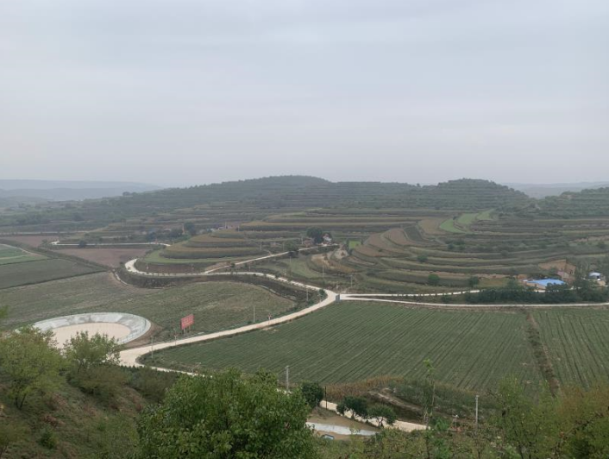  Pengyang county subproject area | 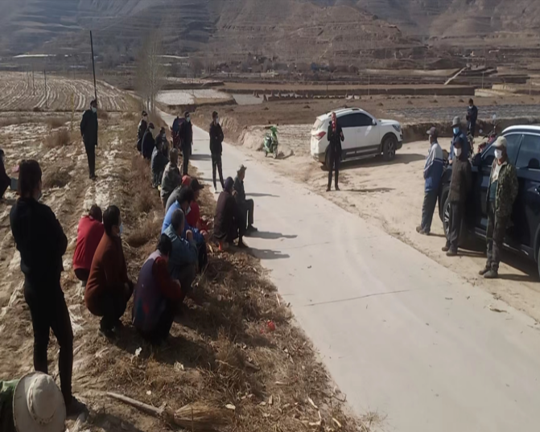  FGD in Xingqing District | 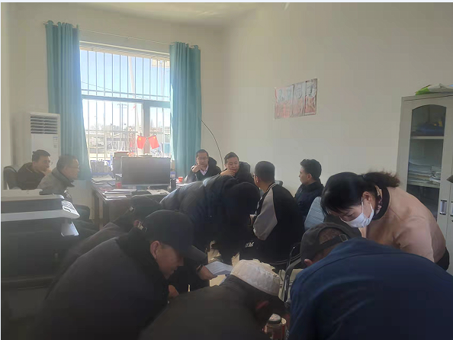  FGDs in Gonghe County
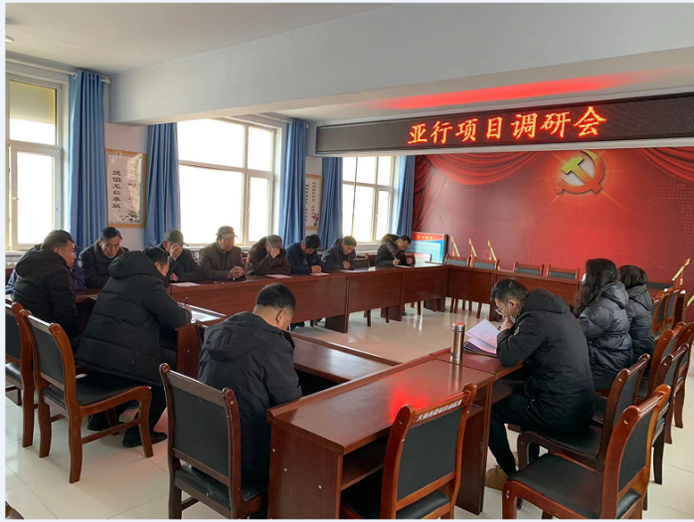  FGD in Huzhu County | 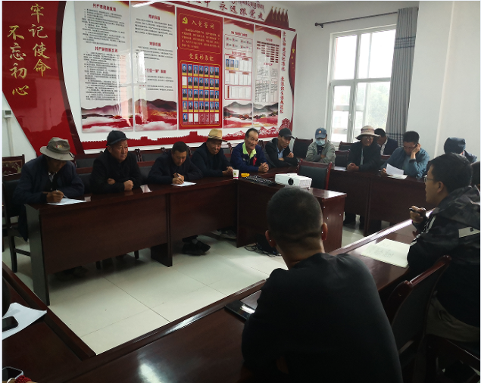  FGD in Huangyuan County | 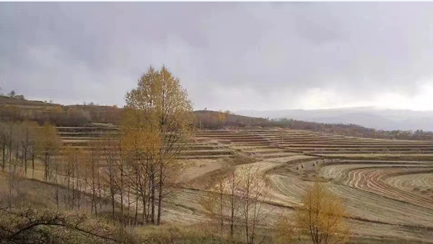  Huangyuan County subproject area
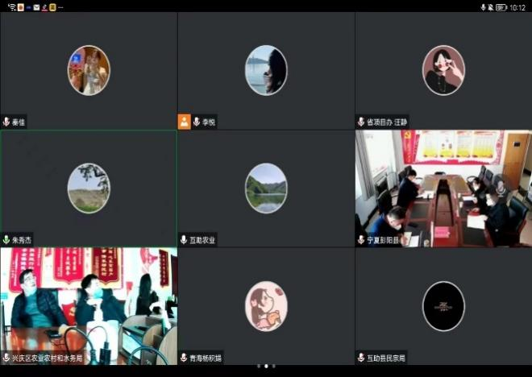  FGDs with PPMOs,CPMOs and ERAC of Qinghai and Ningxia | 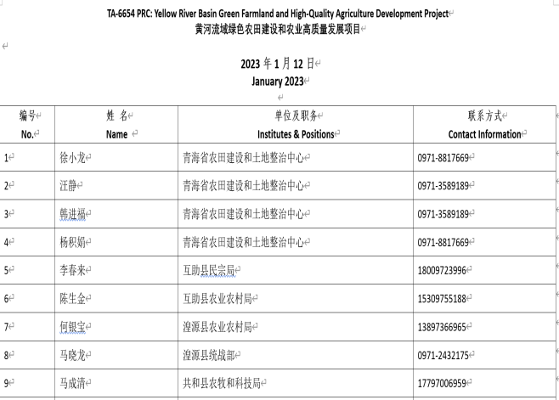  Sign in form of FGDs from Qinghai | 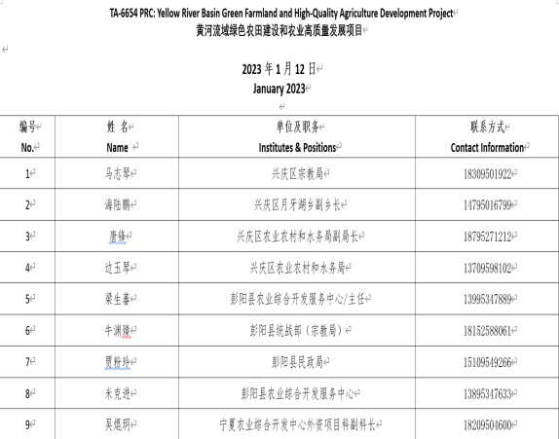  Sign in form of FGDs from Ningxia
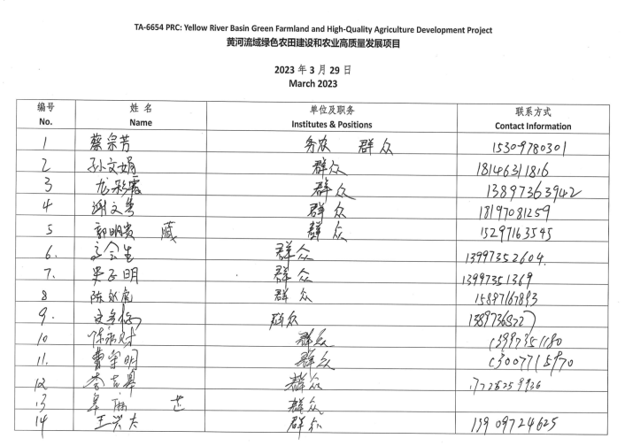  Sign in form of Xiaogaoling village FGDs in the Huangyuan County, Qinghai(I) | 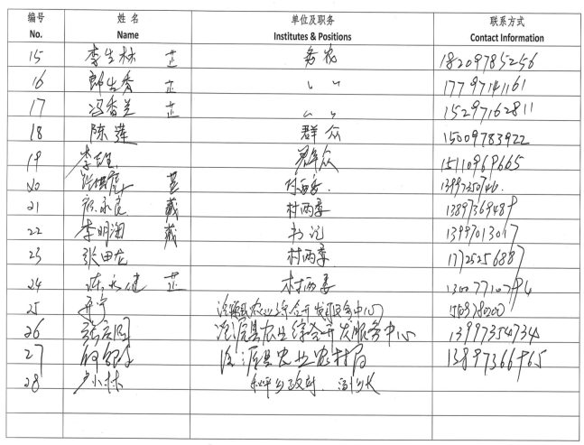  Sign in form of Xiaogaoling village FGDs in the Huangyuan County, Qinghai(II) | 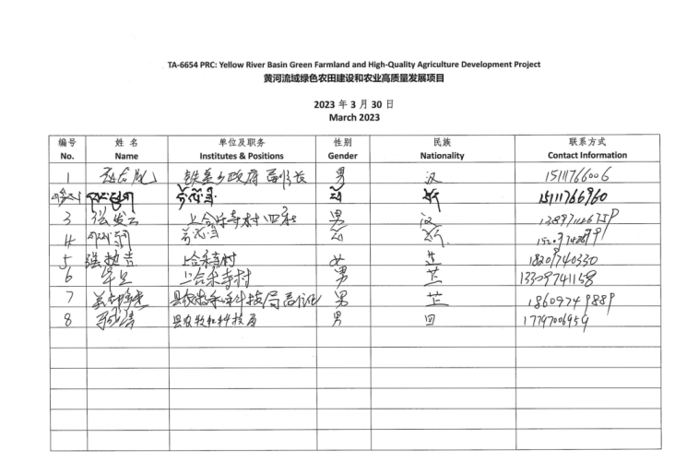  Sign in form of Shanghele village FGDs in the Gonghe County, Qinghai
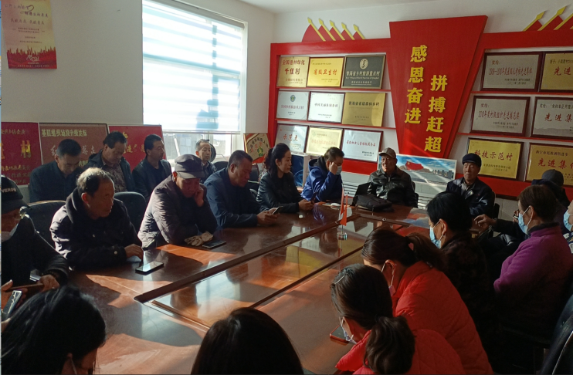  Xiaogaoling village FGDs in Huangyuan County, Qinghai (I) | 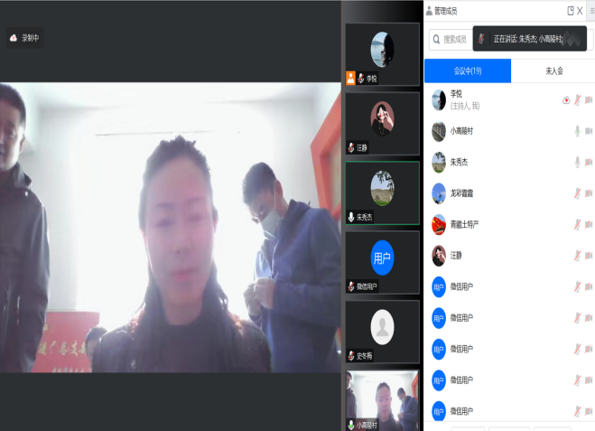  Xiaogaoling village FGDs in Huangyuan County, Qinghai (II) | 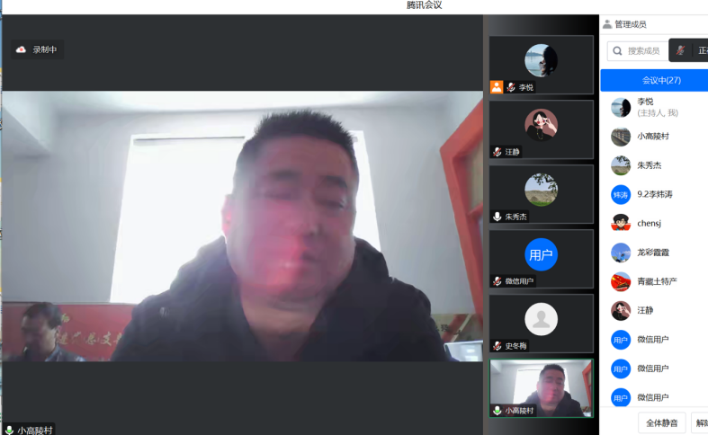  Xiaogaoling village FGDs in Huangyuan County, Qinghai (III)
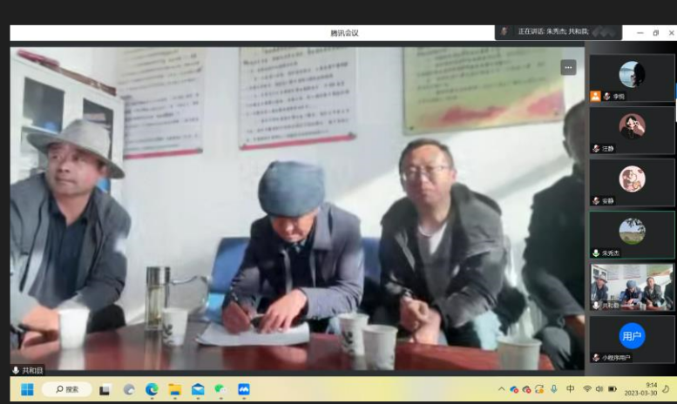  Shanghele village FGDs in Gonghe County, Qinghai (I) | 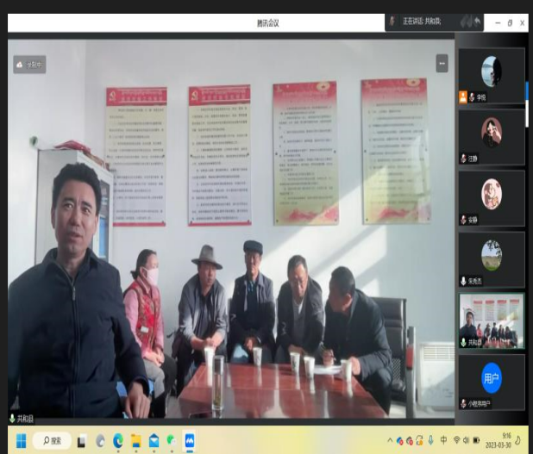  Shanghele village FGDs in Gonghe County, Qinghai (II) | 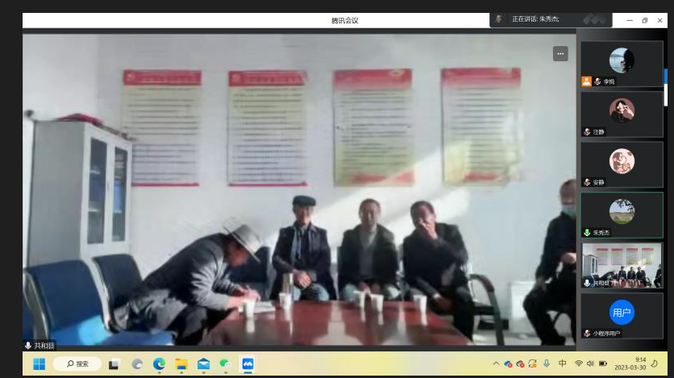  Shanghele village FGDs in Gonghe County, Qinghai (III)

Low income refers to the population with relatively poor family economic income and is near the local low-income line. On 5 January 2020, the Ministry of Civil Affairs of the PRC issued the opinions on the evaluation and determination of rural minimum living security families. It is recognized from four aspects: wage income, net income from transfer, net income from property and net income from operation. There are differences in the recognition standards of rural low-income families across the country, but they basically refer to the local rural minimum living standard. Some regions stipulate that the per capita income of families is higher than the local minimum living standard, but lower than twice the minimum living standard, and the property status meets the local minimum living standard marginal families. The low-income population in this report includes families receiving the minimum living security and three groups of people (including households with unstable poverty alleviation status, marginal households prone to poverty and households with sudden and serious difficulties).
Low-income groups include (i) the residents eligible for Minimum Living Subsidy (MLS); (ii) the rural residents with a per capita disposable income level less than 1.5 times of national poverty line in 2020 (CNY 4,000), (iii) the households facing severe hardship and eligible for temporary government assistances; and (iv) householders eligible for special difficult family maintenance (former as five-guarantee households).
A household survey was conducted in 2021. In 2023, a supplementary survey was carried out. See para 58 for more information.
www.adb.org/accountability-mechnaism

